**Project on   
Hardware Sales and Purchase System**



**LIRAJ MAHARJAN**

**00162808**

**Computing Project**

**Level 5 Diploma in Computing**

**Softwarica College of IT and E-Commerce**

**Kathmandu, Nepal**

**13 July 2017**

Table of Contents

1. Introduction 7

1.1 Aims 7

1.2 Objectives 7

1.3 Development methods 7

2 Analysis 8

2.1 Rich picture 8

2.2 System Requirement Specification (SRS) 9

2.2.1 Functional Requirements 9

2.2.2 Non-functional Requirements 12

2.3 Prioritization 14

2.4 Use case diagram 15

2.5 Architecture 18

2.5.1 System Architecture 18

2.5.2 Initial Class Diagram 18

2.6 Conclusion 21

3 Design 22

3.1 Structural Diagram 22

3.1.1 Class Diagram 22

3.2 Behaviour Diagram 24

3.2.1 Activity Diagram 24

3.2.2 Sequence Diagram 26

3.3 Database Design 35

3.3.1 Entity Relationships (ER) Diagram 35

3.3.2 Data Dictionary 37

3.4 Conclusion 40

4 Implementation 41

4.1 Programming Language and Web design 41

4.1.1 Hyper-text Preprocessor (PHP) 41

4.1.2 Hyper-Text Markup Language (HTML 5) 41

4.1.3 Cascading Style Sheet (CSS) 41

4.1.4 Java Script 42

4.1.5 Bootstraps 42

4.1.6 Code Igniter Framework 42

4.1.7 MySQL 42

4.2 Development Environment 42

4.2.1 Integrated Development Environment (IDE) 42

4.2.2 Development Platform 42

4.3 Development Strategy 43

4.3.1 System Migration 43

4.3.2 Data Migration 43

4.4 User Training 43

4.5 Conclusion 44

5 Other Project Issues 45

5.1 Project Management 45

5.2 Risk management 45

5.2.1 Identifying Risks 45

5.2.2 Assess of impact of risks. 46

5.3 Configuration Management 48

5.4 Testing 48

5.4.1 Unit Testing: 48

5.4.2 White Box testing: 48

5.4.3 Black Box testing: 49

5.4.4 Integration testing 49

6 Conclusion 54

7 Future works 55

8 References 56

Appendices 57

Appendix A 57

Appendix B 64

Appendix C 76

**Table of Figures**

Figure 1: Rich picture for Hardware Sales and Purchases System 5

Figure 2: MoSCoW of Hardware Sales and Purchase System 11

Figure 3: Usecase of actor and supplier of Hardware Sales and Purchases System 12

Figure 4: Use case of staff and customer Hardware Sales and Purchases System 13

Figure 5: Initial class diagram of Hardware Sales and Purchases System 17

Figure 6: Final class diagram of Hardware Sales and Purchases System 20

Figure 7: Activity diagram of Hardware Sales and Purchases System for customer and staff 22

Figure 8: Activity diagram of Hardware Sales and Purchases System for owner and supplier 23

Figure 9: Sequence diagram of owner registration 24

Figure 10: Sequence diagram of owner login 25

Figure 11: Sequence diagram of owner activities 26

Figure 12: Sequence diagram of staff login 27

Figure 13: Sequence diagram of staff login 27

Figure 14: Sequence diagram of staff page 28

Figure 15: Sequence diagram for customer registration 29

Figure 16: Sequence diagram of customer login 29

Figure 17: Sequence diagram of customer page 30

Figure 18: Sequence diagram of payment 31

Figure 19: ER diagram of Hardware Sales and Purchases System 33

Figure 20: Data dictionary of table CUSTOMER 34

Figure 21: Data dictionary of table STAFF 34

Figure 22: Data dictionary of table SUPPLIER 35

Figure 23: Data dictionary of table ORDER 35

Figure 24: Data dictionary of table PIPE&FITTINGS 35

Figure 25: Data dictionary of table SALE 36

Figure 26: Data dictionary of table STAFCUSTOMER 36

Figure 27: Data dictionary of table STAFFSUPPLIER 36

Figure 28: Data dictionary of table STAFF_TYPE 36

Figure 29: Risk likelihood values 43

Figure 30: Risk consequence values 43

Figure 31: Risk Management table for HSPS. 44

Figure 32: Test report of HSPS project. 50

**Abstract**

The purpose of my project is to model Hardware Sales and Purchase Shop or System (HSPS) facilities and services provided by them into website. The HSPS has no any official website through which they can advertise their item to online market. They have been doing very well with offline services but they want to extends their services into online also. They want their website to be able to perform sales and purchases also. I have aimed to develop this project by dividing them into small parts i.e. analysis, design, implementation and testing.

Its aim is to extends the business in all over Nepal through WWW and international also if any customer is willing to buy. Although the shop will be opened from 9:00 am to 6:00 pm, website will be opened 24 X 7 for customer. Customer can place order form anywhere within Nepal and will guarantee deliveries within 1 days inside Kathmandu, Bhaktapur and Lalitpur and within 5 days outside these three valleys. We promise to be in time. Staff will accept the placed order and prepare bill as per the pipe and fittings given in order and pass it to deliver staff to deliver the pipe and fittings. Owner of the HSPS will keep the track on each and every activity that have been carried out daily. He will also deal with the supplier to purchase pipe and fittings and maintain the sales and purchases so we are not out of stocks. He will add new staffs, supplier and pipe and fittings and also can modify as per needed. He can also delete the customer if those customers are no more related with the shop. the website I will be developing will be easier to user and also reliable and secure.

Hence this HSPS project might lead this shop to another level of business goals.

.

**Acknowledgement**

Hardware Sales and Purchases System (HSPS) was an exciting project to do for me. It helps me a lot to know about how a system must be look alike? and what a system should do? I would like to thank specially to my teacher **Mr. Sudeep Lal Bajimaya** as well as **NCC** who gave me this opportunity to do an ideal project. It makes me do lot of research by which I came to know so many new things.

I would also like to express my gratitude to **Mr. Manoj Shestha** sir for idea about professional issues in IT and how to deal with such issues and **Mr. Dhurba Gyawali** sir for teaching me PHP as well as Web Design using Code Igniter framework. Also for supporting, coordinating and providing me good guideline throughout the project by above mention teachers.

I also want to thank my friends and family for supporting me to accomplish this project. I also want to thank to **Mr. Ashok Man Maharjan** uncle for helping in this project by giving proper guidelines for how the shop works. He has also provided details information about pipe and fittings to me.

This project is not just a project for academic certificate but it’s also a resources to increase my knowledge and skills.

Once again THANK YOU to all who helped me in this project.

# Introduction

Hardware Sales and Purchase Shop (HSPS) is situated in Teku, Kathmandu which sales pipe and fittings that have been manufacture by Panchakanya Group. It is one the renowned hardware shop of Kathmandu valley. It a regular dealer of Panchakanya Group. It serves its customer as well as other hardware shops also by selling them PPR and CPVC pipe and fittings.

The system they are using currently are only just for entering daily transaction. They don’t have any platform to advertise their items and services they have been providing since 30 years. Rabindra is the manager as well as owner of the shop who deals with supplier and customer for buying and selling the pipe & fittings. They have 6 staffs with specific task they will perform for the shop. Prasad, Saurav and Shyam will delivers the product that have been sold from the shop counter to customer, Sofia and Kritika will enter transactions that are made with customer as well as supplier and Komal with serve customer, staff and manager with tea and refreshment.

With the growing technology manager want to have their own website through which they can sale pipe and fittings they have in their go down. It can enhance the business strategy as well as the customer will also find them easy to deal with. The website must provide details information of shop and its services and facilities. It should provide platform for owner, staff and customer to get register and logged in. It should also include the pipe and fittings details show that customer can order the size and quantity of the product.

## Aims

The major aims of HSPS are listed below:

1. To automated the financial transaction that is being performed daily.
2. To provide as much as possible services to customer and attract more customer.
3. To build a web based application for e-commerce.

## Objectives

The main objectives of HSPS are listed below.

1. To gather information about shop from stakeholder and what they want.
2. To analysis the requirement and design as per stakeholder.
3. To keep all the records of customer and supplier.
4. To analyze most product consumed by customers.
5. To build easy and reliable website.
6. To bring latest product in the market.
7. To test and document them for future references.

## Development methods

I have chosen waterfall model for developing this project. It is simple to implement and easy to make use of it. The steps involve in it makes this project to build successfully because this method include each and every necessary process that must be used in developing project. It consists of feasibility, study, requirements analysis, system design, implementation, testing and maintenance. The steps are taken one after another which helps in another steps. This is easy to implement and understand in less economic. A proper management with time scheduling can met the deadlines to accomplish one step at a particular time.

# Analysis

System analysis identifies the information requirements that must be met by a system solution. It helps to known to current situation of the shop and gather information or requirements to upgrade the shop status. In this phases details analysis of the systems is conducted to access the feasibility of solution and alternative solutions, cost benefits, advantage and disadvantage of each alternative. It is up to the user to decide most suitable solution.

Better analysis produces better and reliable output. So analysis must be done as deep as it can go so it won`t be any problem in future. I have done analysis by distributing it into many parts such as rich picture, system requirements specification, use case and initial class diagram which help to understand the requirements of the shop.

## Rich picture

It is a way of exploring the system and its situation which is expressed through diagram. It helps to open discussion among the shareholders and for better understanding of system needs. It shows the necessary fundamentals of the system. It shows processes and how those are interrelated with each other’s.

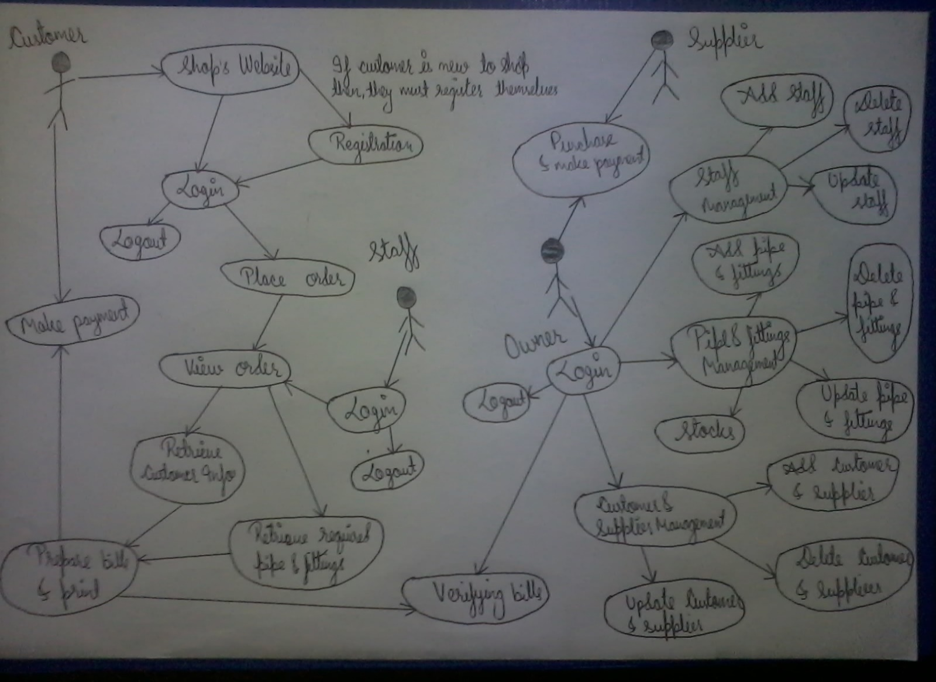

Figure 1: Rich picture for Hardware Sales and Purchases System

## System Requirement Specification (SRS)

It refers to analyzation summarization of system requirements by conducting various methods or processes like interview by preparing appropriate questionnaire, observation of staff and customer and other similar activities related to gathering information. It is further divided into functional and non-functional requirements.

### Functional Requirements

It describes the functional requirements of the system; like what it really need to do. It includes data control, authentication, verification, function and methods, rules and regulation and many more which is required to run the system. However, its defines set of inputs, processes and required outputs.

Some of the functional requirements for HSPS are given below:

**ID:** FR1

**Title:** Owner/Staff and Customer Registration

**Description:** Owner/Staff and Customer must be able to register themselves in the system. They should provide username and password for registration.

**Rational:** To get information to logged into system

**ID:** FR2

**Title:** Owner/Staff and Customer Login

**Description:** Owner/Staff must be able to logged into system with their username and password. After login they can get access to other function of the system.

**Rational:** To be able to get access into system.

**ID:** FR3

**Title:** View Report

**Description:** Owner/Staff should be able to view information of customer and supplier. They must also view the products that are available at shop.

**Rational:** To know the details information of customer and supplier and stocks.

**ID:** FR4

**Title:** Purchase

**Description:** The system must provide platform to keep the record of purchases item and store them in a database.

**Rational:** Staff must be able to view purchase item whereas Owner can view and add the purchase items.

**ID:** FR5

**Title:** Sale

**Description:** The system must be sale their product to the customer as per their requirements.

**Rational:** Staff can sales the items and view them as well as Owner can also view the sold items.

**ID:** FR6

**Title:** Stock Management

**Description:** The system must be able to manage stock so that it can display sales, purchases and balance of the pipe and fittings.

**Rational:** Sometimes shop might be run out from the stock. So to prevent from this risk stock management can inform before all the stock are cleared out.

**ID:** FR7

**Title:** Prepare bills

**Description:** The system should be able to generate bills with automatic calculation including all the taxes.

**Rational:** To make the bill system automated and reliable.

**ID:** FR8

**Title:** Shop details and its services

**Description:** The system must be able to provide required information to new customer and supplier such as contact number, address, email and many more.

**Rational:** To keep in touch with customer and supplier.

**ID:** FR9

**Title:** Details of pipe & fittings, customer and supplier

**Description:** System must be able to provide details information of pipe & fittings, customer and supplier quickly as per needed.

**Rational:** To do further study and produce better output.

**ID:** FR10

**Title:** Manage Customer and Supplier

**Description:** It must be able to add new customer and supplier and edit or update and delete existing customer and supplier details.

**Rational:** To be updated with information of customer and supplier.

**ID:** FR11

**Title:** Manage pipe & fittings

**Description:** It must be able to add pipe & fittings with their price and edit or update and delete existing pipe & fittings details.

**Rational:** To be updated with price and other products of the shop.

**ID:** FR12

**Title:** Place order

**Description:** Customer who have logged in and want to buy pipe and fittings must be able to place order online.

**Rational:** To make easier for customer to order an item and make build better relationship with customer.

**ID:** FR13

**Title:** View order

**Description:** Staff must be able to view the items ordered by customer to prepare bill and deliver pipe and fittings as per order.

**Rational:** To make sure which items are customer willing to pay for.

### Non-functional Requirements

The system can`t be totally successful with only functional requirements, there are many other things which help the system more efficient and effective. Such things are known as non-functional requirements. It defines the accuracy, capacity, smoothness and dependencies of the system.

Some of the non-functional requirements of HSPS are given below:

**ID:** NR1

**Title:** Speed

**Description:** System must perform the all the activities within certain period of time with accurate data processing.

**Rational:** To get the required data quickly and effectively.

**ID:** NR2

**Title:** Availability

**Description:** The system must be available for all the time when the shop is opened whereas website is for 24 X 7.

**Rational:** To access the database and features in working hours.

**ID:** NR3

**Title:** Reliability

**Description:** All the activities of shop are going to be automated so it should be reliable and cannot harm others also.

**Rational:** To make owner/staff use the system more often rather than doing manually.

**ID:** NR4

**Title:** Maintainability

**Description:** It should me maintainable if any problem occurs and system must be up to date.

**Rational:** To run the system smoothly without any disturbance.

**ID:** NR5

**Title:** Security

**Description:** Security is most important part of the system nowadays. So security must be provided in every required places.

**Rational:** To make data more secure.

**ID:** NR6

**Title:** Usability

**Description:** Moreover, the system must be usable and provide required platform.

**Rational:** To make understandable and informative system for owner/staff.

**ID:** NR7

**Title:** Compatibility

**Description:** It should be able to work with any devices and any browser.

**Rational:** To provide facility to every possible user.

**ID:** NR8

**Title:** Data Integrity

**Description:** The data must be accurate and consistency in the output.

**Rational:** To provide accurate data.

**ID:** NR9

**Title:** Adaptability

**Description:** It should be able to adjust with the new requirements of the shop.

**Rational:** To perform continuously without any problem

**ID:** NR10

**Title:** Back up

**Description:** Backup must be done daily because daily sales and purchase activities are carried out so to prevent from data loss back up must be done.

**Rational:** To recovery of data in case of loss of data.

## Prioritization

It is the process of identifying the important needs and function of the system. While performing SRS many requirements are identified. Although, all the features and functions are needed to be develop there are some requirements which are less prioritized for the moment. I have use MoSCow for performing prioritization. MoSCow refers to

**Must Have:** It refers to most important requirements of the system

**Should Have:** It refers to important but not necessary for delivery for current time.

**Could Have:** It refers to desirable but not important and can be update later.

**Won’t Have:** It refers the features that have been demanded but unfortunately can’t develop at a given time.

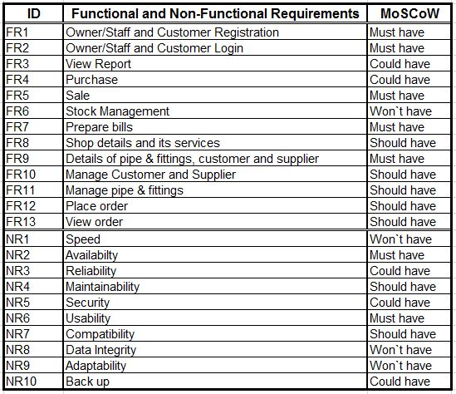

Figure 2: MoSCoW of Hardware Sales and Purchase System

## Use case diagram

It is the diagrammatical representation of identifying, analyzing, clarifying and organizing system requirements in a scientific manner. It shows the activities done by each individual suck as owner, staff, customer and supplier. They are represented by stickman whereas activities or process of the system is represented by entities and its dependencies. It also help to identifies functional and non-functional requirements of the system

Use case diagram for HSPS are given below

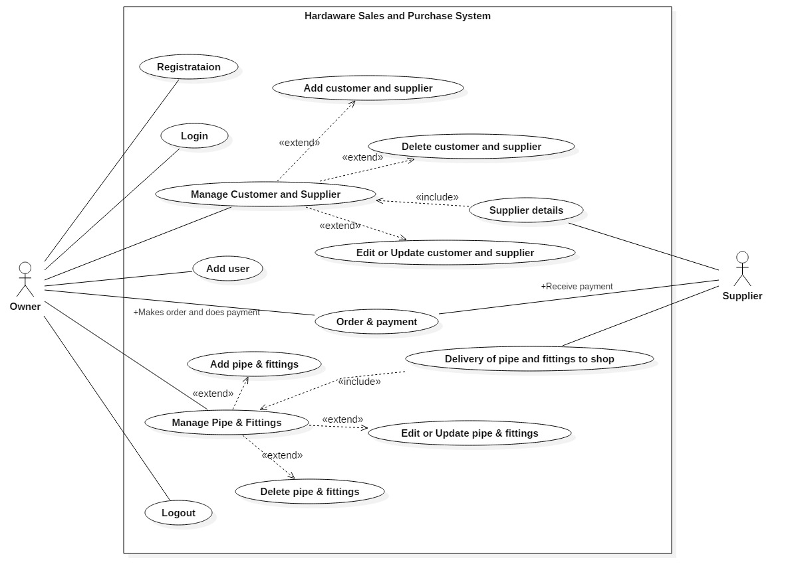

Figure 3: Usecase of actor and supplier of Hardware Sales and Purchases System

Use case description of Hardware Sales and Purchases System for Owner and Supplier are listed below:

1. Owner can register himself by providing his required personal details.
2. After registration he/she can login to access the features and functions of the system.
3. He/she can manage customer, supplier and pipe & fittings like add, update or delete.
4. He/she can make order to supplier for required pipe and fittings and make payment after the delivery.
5. Owner can make themselves logged out if there are no any work to perform.
6. Supplier provides a details information of themselves including products they have manufactured.
7. Supplier takes order from owner and delivery as per required list and takes payment.

Use case for staff and customer for HSPS

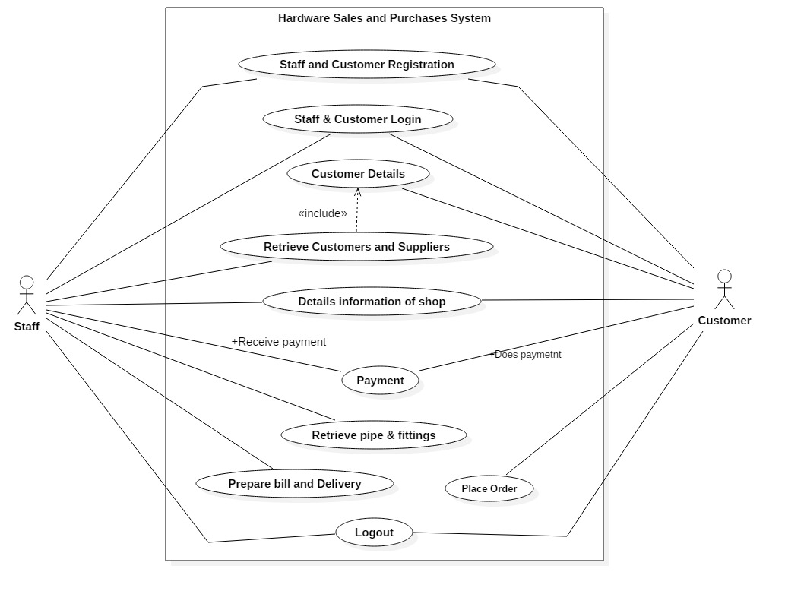

Figure 4: Use case of staff and customer Hardware Sales and Purchases System

Use case description of Hardware Sales and Purchases System for Staff and Customer are listed below:

1. Staff also can register themselves by providing their information.
2. After registration he/she can login to access the features and functions of the system.
3. Staff can retrieve data which the Owner has entered into database for sales and purchase system.
4. He/she can also view the webpage of shop and update them if required.
5. Staffs also prepare bills and print them if required.
6. Staffs are also able to logged out from the webpage while it is not required.
7. Customer also visit the website and place order online.
8. If the customer is new to website, then they must register themselves before login a place order.
9. Payment is done at the same time when ordered pipe and fittings are handover to customer.

## Architecture

Architecture refers to structure of how the whole system is going to be completed or develop. It is a prototype of system that explains how all the features and functions are going to work together for better output. It also includes system performance, usability, availability, security and many more related to non-functional requirements.

### System Architecture

It defines the structure and behavior of the system that represents how the whole system is going to work. It is based on a tool known as architecture frame work. It is the platform where functional activities are divided into different object and makes them easier to handle in complex situation. I have chosen Model View Controller (MVC) design pattern to work with. Model refers to data and method used to work with. View represents the visualization of the data that model contains whereas Controller represents the classes connecting the model and the view and relation between them.

### Initial Class Diagram

Class diagram refers to diagrammatical represents of classes including their attribute of HSPS. It also shows the relationship and cardinality between classes used in HSPS. It also gives the function or methods that are used in this HSPS.

Initial class diagram is just a prototype of original class diagram that shows there would be following classes with its functions. It is done as a conceptual class diagram where possible classes and their attributes are portrait.

#### Scenario

Hardware Sales and Purchase Shop is one of the reputed hardware shop situated in Teku, Kathmandu. It provides facility of buying pipe and fittings in an affordable price. It procured pipe and fittings with particular supplier and sales them to the customer who are willing to purchase these pipes and fittings.

Now, the shop wants to go more further by starting business into e-commerce as Hardware Sales and Purchase System (HSPS). The shop manager wants me to develop a shop`s website through which he can sale the product of the shop. The website must contain the following features:

1. Detail information of shop and services provided by it.
2. Owner, staff and customer registration and login.
3. Pipe and fittings specification and its price.
4. Staff, customer and supplier details.
5. Provide customer with facility of placing order they are willing to buy.
6. Owner must be able to view the details of customer, staff and supplier and manipulate them.
7. Staff must be able to view the order placed by the customer.
8. Stock management should be done while purchases and sales are carried out.

#### Natural Language Analysis (NLA)

It is the process of identifying classes, attributes and its function by doing proper analysis of system. It identifies nouns, verbs and adjectives which represents classes, attributes and functions respectively.

The following NLA is done by analyzing the given scenario. Here, are the initial NLA process done by analyzing the system requirements.

|  |  |
| --- | --- |
| Classes (Noun) | Verb (methods) |
| owner, staff, customer, user, shop, login, business, item, supplier, pipe & fittings, order, manager. | Monitor, order, add, update, delete, report, view, control and many more. |

After doing the initial NLA process the proper classes and methods are identified.

|  |  |
| --- | --- |
| Classes | Verb |
| Owner, Staff, Customer, Supplier, Shop | Add, update, delete, view, register, login etc. |

Initial class diagram of HSPS

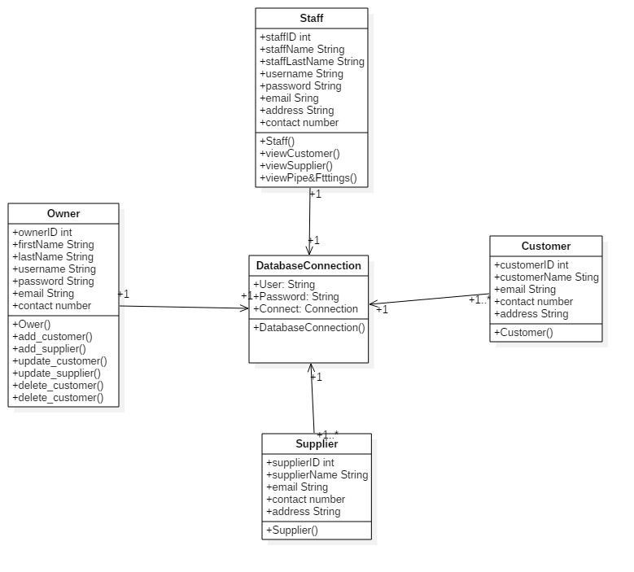

Figure 5: Initial class diagram of Hardware Sales and Purchases System

In the above Figure 5, its shows the 5 possible classes of HSPS. Owner, Staff, Supplier and Customer will be used to keep the record of owner`s detail, staff`s details, supplier`s details and customer`s detail details respectively. It also shows the function will be performed by a specific class such as adding, deleting and updating the information of owner, staff, customer and supplier. Here, DatabaseConnection class will be used to connect database where all the data gained by the respected classes will be stored.

## Conclusion

Finally, the analysis was done using various traditional and modern technology for Hardware Sales and Purchases System. Firstly, I have done requirements analysis which consists of functional and non-functional requirements. Later prioritization was conducted using MoSCoW method which helps to identify the must have, should have, could have and won`t have features and functions of the HSPS. Use case diagram was also prepared while doing analysis for better understanding of the system and relation among the entities of HSPS. Lastly, the initial class diagram was prepared to know the functions that must be used to develop the system.

# Design

Analysis describes what a system should do to meet the requirements of the Hardware Sales and Purchases System (HSPS) and design shows how the system will fulfil the objectives of system. The design of the system is the overall plan or model for that system. To design the system, the team or an individual can use top-down design or bottom-up design model. A design can be conceptual, logical and physical. It must be done with proper visualization of the system for better result in the development. The system design method such as activity diagram, class diagram, ER-diagram, flow-charts, data flow diagram (DFD) etc. are used in this phase.

For the designing phase I have use Unified Modelling Language (UML) diagrams for better understanding of the system. UML is a platform for designing, portraying and documenting the concept of how the system works and its functional and non-functional activities. It can represent both static and dynamic view of the system. It`s just a platform for designing or modelling language which helps to develop (coding) the system easily and effectively.

With various IDE available for modelling, I have preferred StarUML and Visual Paradigm tool to construct the various diagram. It provides necessary tools while drawing such diagram. I have used StarUML for Class diagram and for ER-diagram, Sequence diagram and Activity diagram in Visual Paradigm. Data dictionary is also included which is construct in MS Excel.

I have further divided design methodology into structural, behavioural and design related to database design.

## Structural Diagram

Structural modelling refers to the static features and framework for the system. It works as a elements and the mechanism to assemble system effectively. It consists of class diagram, deployment diagram, component diagram and many other diagrams. Among them I have chosen to class diagram to go with.

### Class Diagram

It represents the static view of the HSPS by analysing and designing. It describes the attributes, operation and constraint used in the system. It is not only used for describing the aspects of a system but also for constructing executable code. It shows relationships, association, aggregation, interface among two different classes.

Here, is the final class diagram of Hardware Sales and Purchases System (HSPS).

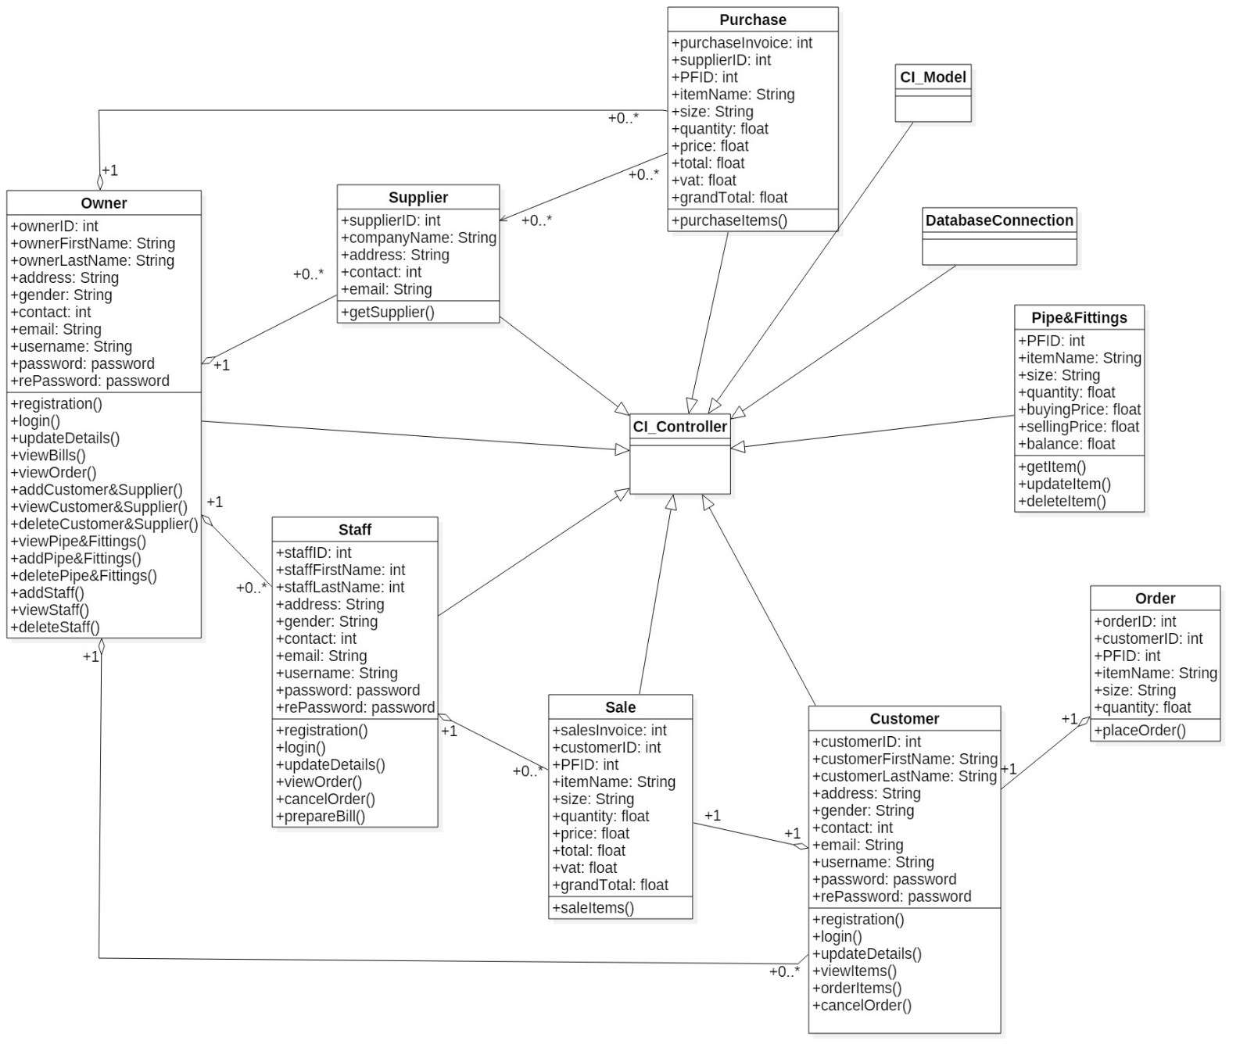

Figure 6: Final class diagram of Hardware Sales and Purchases System

In the above Figure 6, it contains of different classes having specific attributes and functions along with CI_Controller, CI_Model and DatabaseConnection. CI_Controller controls all the classes and make relationship with other classes to operate the system smoothly where as CI_Model is the collection of data and methods. DatabaseConnection is used to configure the database connection for storing the data generated through controller, view and model. The class diagram shows generalization, relationship and aggregation between two classes.

## Behaviour Diagram

Behaviour modelling represents the interaction between user and system of HSPS. It refers to dynamic features of the system. It shows the functions or logic of the system how the system should perform. It consists of Activity diagram, Sequence (Interaction) Diagram, Use case diagram and many more. Among them I have chosen activity diagram and sequence diagram to go with.

### Activity Diagram

It refers to activity that flows within the system. Basically, it’s a flowchart that represents the flow from one activity to another activity. It shows how owner, staff and customer of HSPS are going to interact with the system. It is used to modelling work flow of the stakeholders, business requirements, understanding high level of system`s functions and for further studies of business.

Here is the activity diagram of staff and customer for Hardware Sales and Purchases System (HSPS).

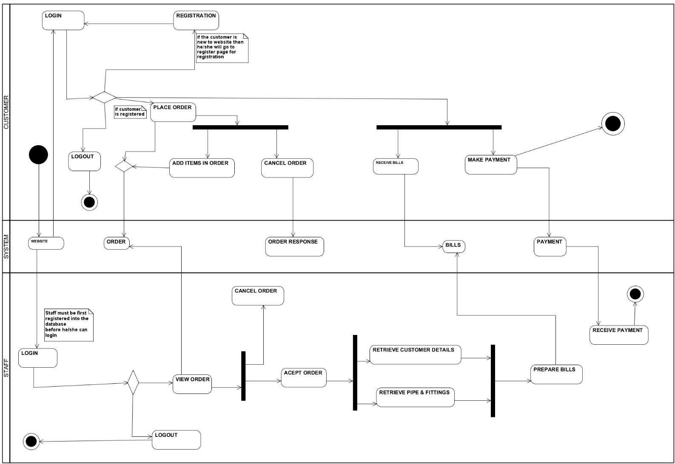

Figure 7: Activity diagram of Hardware Sales and Purchases System for customer and staff

In the above Figure 7, it consists of activities and interaction between system that are done by staff and customer simultaneously. Here, the customer logged into website (if the customer is not registered he/she must have registered themselves) and place order of his/her required pipe and fittings and does payment after the bills is prepared by staff. He/she can also cancel the order if they don’t want ordered items anymore. And in terms of staff, after he/she logged in, they view order placed by the customer and prepare bills from retrieving data from database and receive payment made by customer. Customer and staff also can log out from website if they done have anything to do.

Here, is activity diagram of owner and supplier of HSPS.

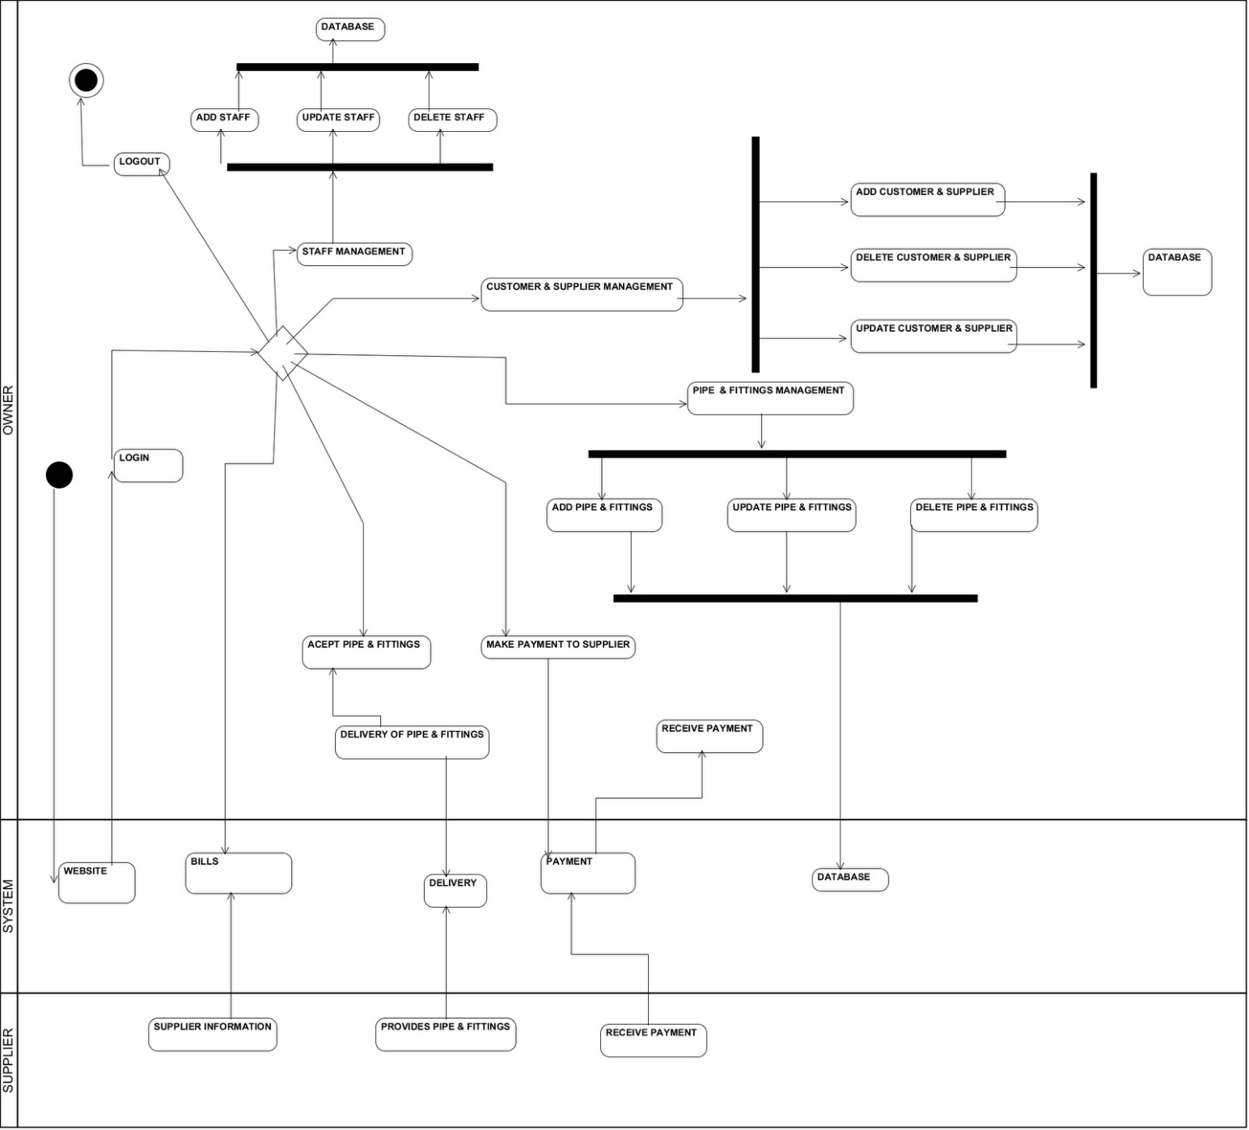

Figure 8: Activity diagram of Hardware Sales and Purchases System for owner and supplier

In the above Figure 8, it shows the activity done by owner and supplier. Owner logged into website and does various related CRUD operation. He/she can add staff, customer & supplier and pipe & fittings and can manipulate them as per requirements. He/she also makes deals with supplier and does payment for purchased item. Supplier provides his/her information and product they have manufactured.

### Sequence Diagram

It is a diagrammatical representation of message flow within the system that makes alert to the user of the website. It not only shows the interaction between users and system but also passage the message as per which activity is currently in operation. It is also dynamic behaviour of the system. It is used for flow control of time sequence and structural organization and message passed by specific activity.

Here, is the collection of sequence diagram of Hardware Sales and Purchases System (HSPS).

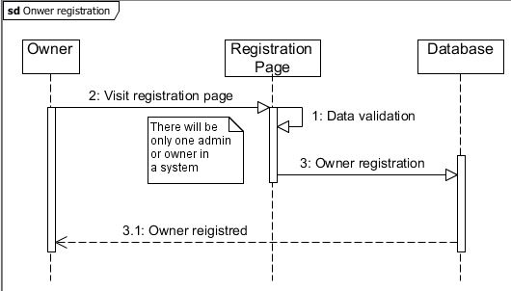

Figure 9: Sequence diagram of owner registration

In the above Figure 9, it consists of owner, registration page and database, where owner is getting registered him/her selves by accessing to registration page. Here, database refers to store the register details into specific table.

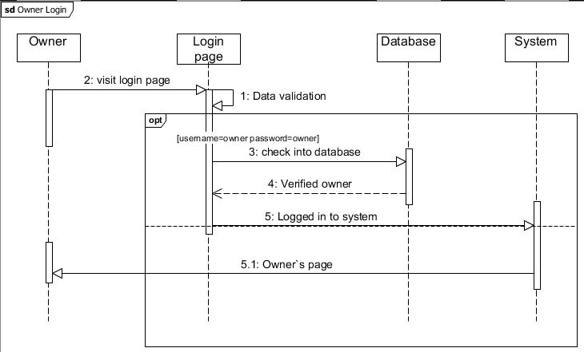

Figure 10: Sequence diagram of owner login

In the above Figure 10, it consists of owner, login page, database and system. Here, owner is trying to logged in with username: owner and password: owner, which helps him to get access to the system and perform several activities. As the username and password matches as per specified then system redirect owner to owner`s page.

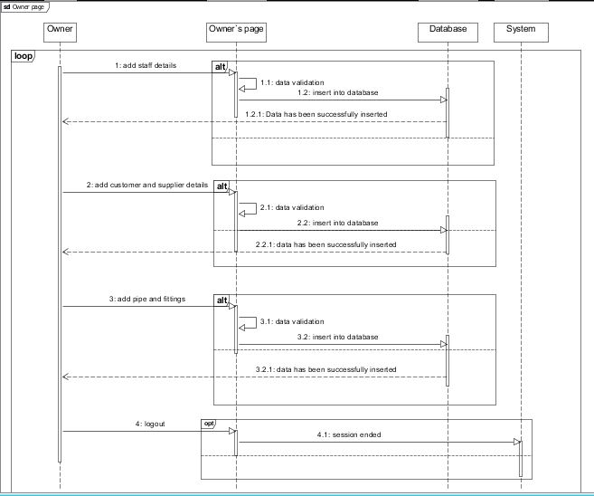

Figure 11: Sequence diagram of owner activities

In the above Figure 11, it consists of owner, owner`s page, database and system. After the owner get logged in into owner`s page, he/she can perform various CRUD operation. System and database collaborate with each other to provide smooth platform for owner to perform his/her activity without any disturbances.

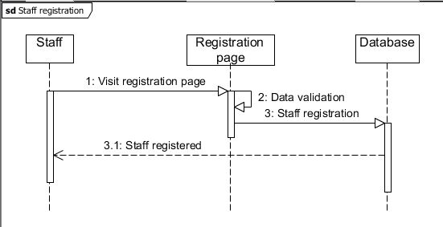

Figure 12: Sequence diagram of staff login

In the above Figure 12, it consists of staff, registration page and database where staff can get registered him/her selves. He/she can later perform activities by getting logged into the system or website. After the completion of registration, staff will be informed with popup message in a dialogue box.

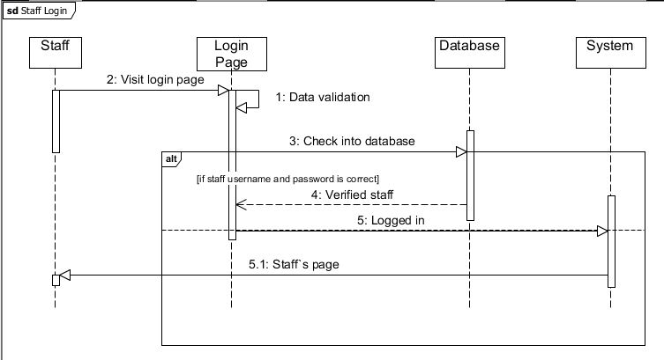

Figure 13: Sequence diagram of staff login

In the given Figure 13, it consists of staff, login page, database and system. With the help of staff username and password he/she can get access to the website and perform various task. If the username and password provided by the staff matches with username and password that is in the database, then system redirect them into staff`s page.

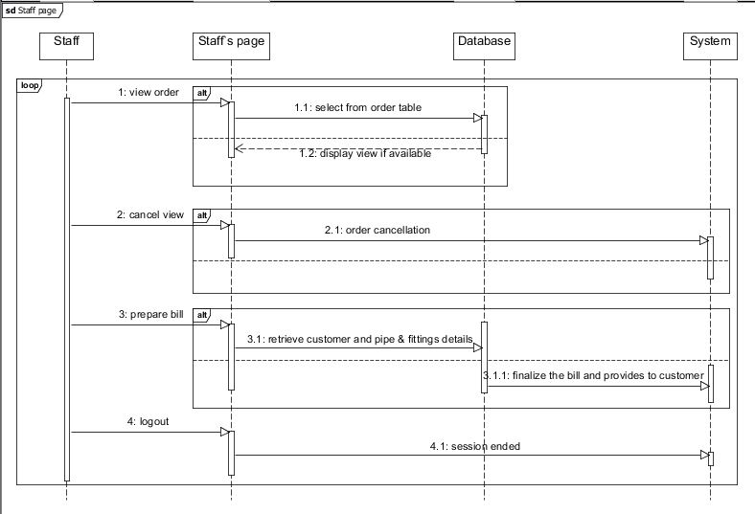

Figure 14: Sequence diagram of staff page

In the above Figure 14, it consists of staff, staff`s page, database and system. After the staff get logged into the system he/she can view order placed by the customer and cancel the order. He/she also prepare the bills as per the customer order and ask for the payment. Here, system plays a vital role for interaction between customer and staff.

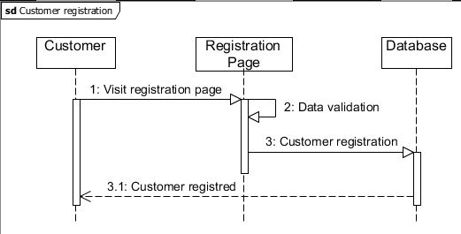

Figure 15: Sequence diagram for customer registration

In the above Figure 15, it consists of customer, registration page and database. It shows how the customer is going to get registered into the system for purchasing the pipe and fittings of available in the database. If customer make it to register him/her selves successfully then pop up message with information will appear.

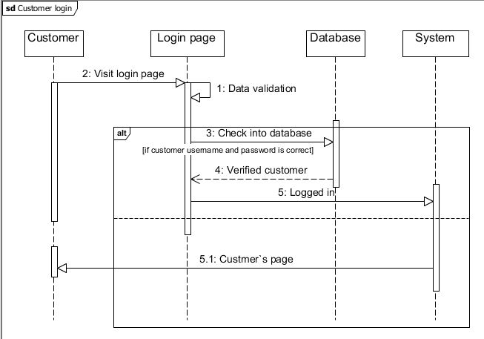

Figure 16: Sequence diagram of customer login

In the given Figure 16, it consists of customer, login page, database and system. Customer can only log in if he/she is registered into database. If the username and password provided by the customer matches will the database username and password, then he/she is redirected to customer`s page.

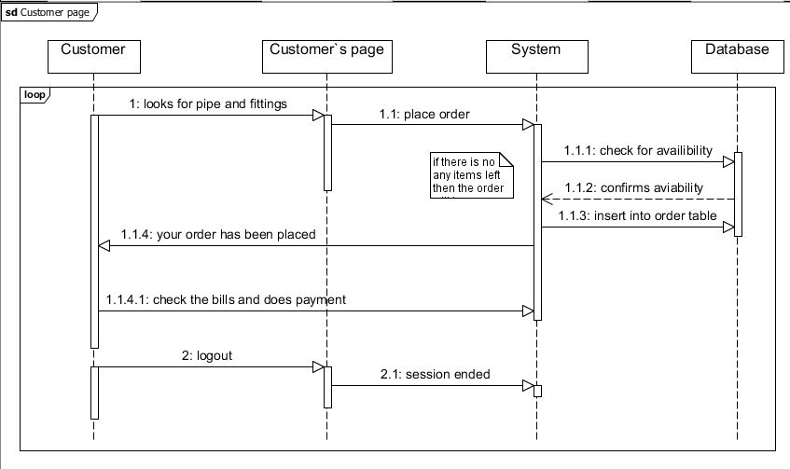

Figure 17: Sequence diagram of customer page

In the above Figure 17, it consists of customer, customer`s page, system and database. When the customer is redirected to customer` page, he/she can place order of the pipe and fittings he/she is willing to buy. He/she also received the bills prepare by the staff and does payment according to particular bill.

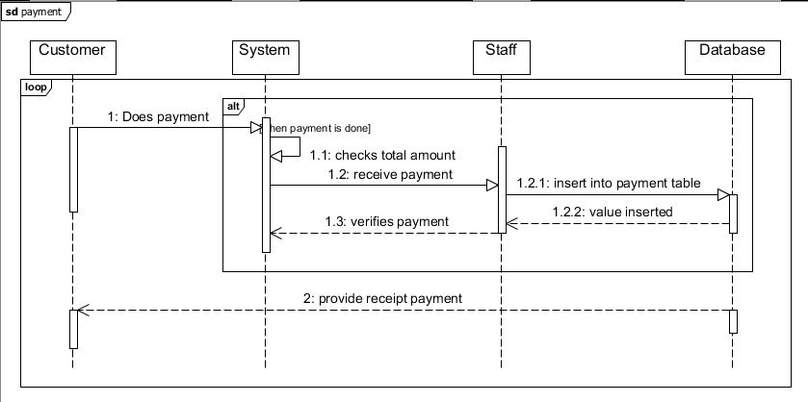

Figure 18: Sequence diagram of payment

In the above Figure 18, it consists of customer, system, staff and database. Customer does payment for the purchased item and Staff received the payment and provide the receipt voucher whereas System works as an interaction between customer and staff.

## Database Design

Database design specifies the data and its structure that should be stored in the database. A good database design is a list of appropriate data that will be included into the database and can be change in the future as per requirements. It also helps in handling the data in easy way as well as enhance the performance of the system. It also shows the relation among the different entities and attributes contain in the entity. Database design can be further divided into Conceptual, Logical and Physical database design. Conceptual design helps to figure out the specific entities and relationships among those entities, Logical design determine the attributes and keys for that entity with the help of normalization whereas Physical design helps to create entity as per definition provided by the Logical design.

There are many different database systems available, among them I have chosen MySQL for HSPS project which I found more comfortable than others. I have considered ER diagram and Data dictionary for this project as a part of database design.

### Entity Relationships (ER) Diagram

ER diagram illustrates how entities are related to each other within a system. It consists of entity, attributes, keys, relationship. Entity refers to the tables of database which can be object, person, animals that provides meaning full information. Attributes refers to properties of that entity where the raw data are stored and make it meaningful. Keys represents the uniqueness of that entity. That can be either primary key, super key, composite key and foreign key represents primary key of another entity. Relationship is the association among two or more entities. It is also known as cardinalities. There are three types of cardinalities One-to-one, One-to-many and Many-to many.

Here, is the ER diagram of HSPS as per analysis done in previous Analysis phase.

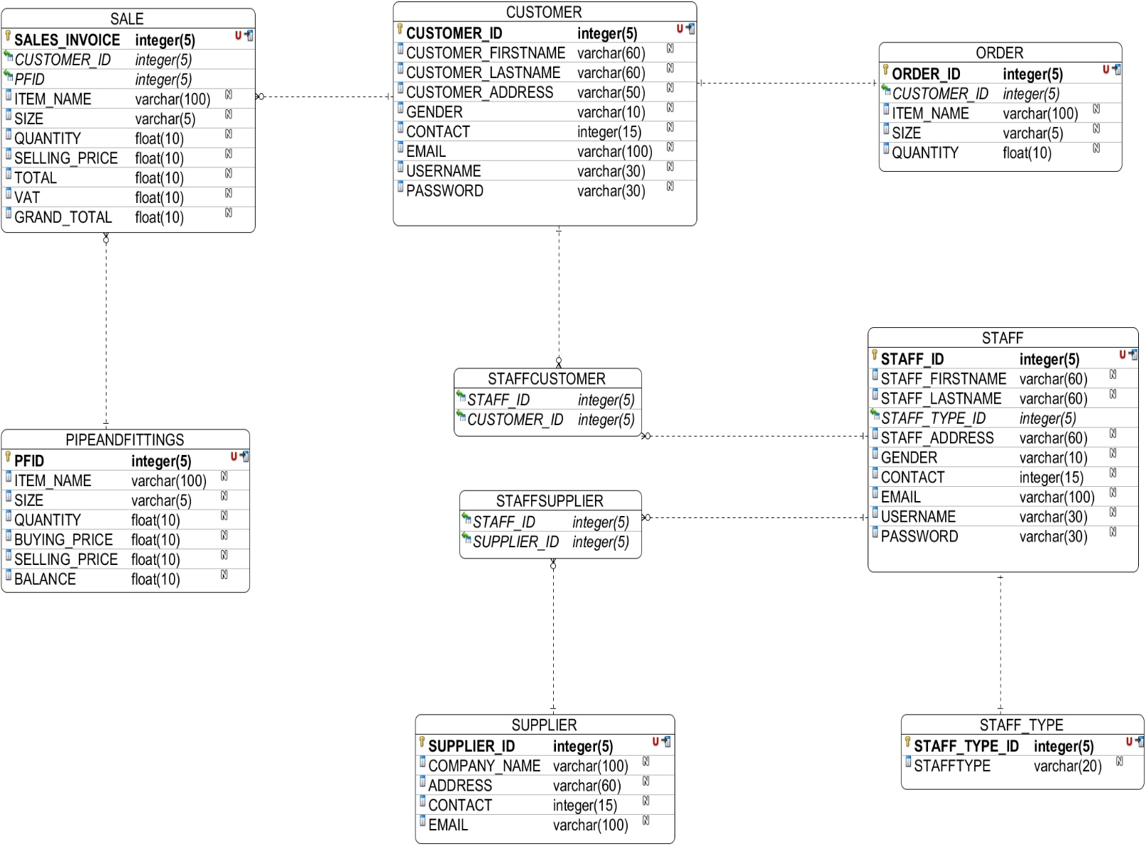

Figure 19: ER diagram of Hardware Sales and Purchases System

In the above Figure 19, there are total of 10 tables such as STAFF, CUSTOMER, SUPPLIER, PIPE&FITTINGS, SALES, STAFF_TYPE, ORDER, STAFFCUSTOMER, STAFFSPPLIER. Here, yellow key represents Primary Key, red U represents Uniqueness and column with black arrow represents indexes whereas column with green arrow represents foreign key. Dotted lines represents the different type of cardinality separated by its ending. It also shows the dependency of the one entity into another. STAFF, CUSTOMER, AND SUPPLIER tables holds the details information of staff, customer and supplier respectively. PIPE&FITTINGS table holds the item with their respective price. ORDER tables holds the items data that are ordered by the customer, STAFF_TYPE holds the records of staff type, entity SALE will record the data that have been sold. And STAFFCUSTOMER and STAFFSUPPLIER is the junction table for CUSTOMER, STAFF and SUPPLIER because of many to many relationships.

### Data Dictionary

Data dictionary is a set of detail information describing structure, format and contents of database. It also describes the entity`s attributes such as its data type, key, length, null able value and its constraint and relationship between among attributes or elements of two different entities.

Data dictionary of table CUSTOMER

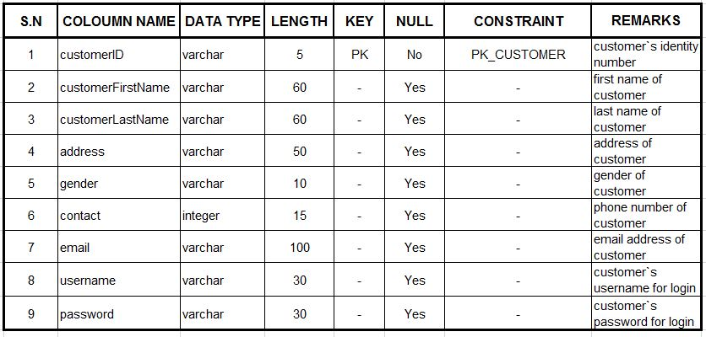

Figure 20: Data dictionary of table CUSTOMER

Data dictionary of table STAFF

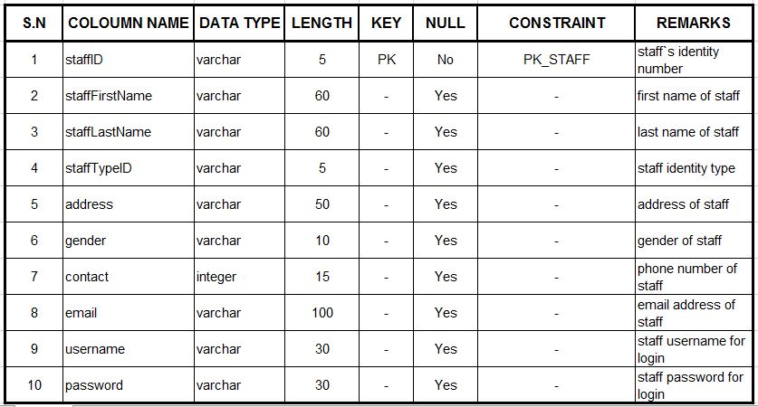

Figure 21: Data dictionary of table STAFF

Data dictionary of table SUPPLIER

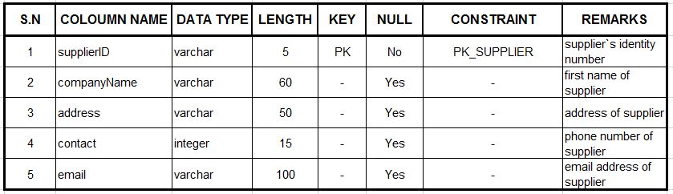

Figure 22: Data dictionary of table SUPPLIER

Data dictionary of table ORDER

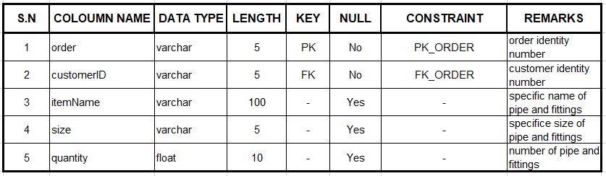

Figure 23: Data dictionary of table ORDER

Data dictionary of table PIPEANDFITTINGS

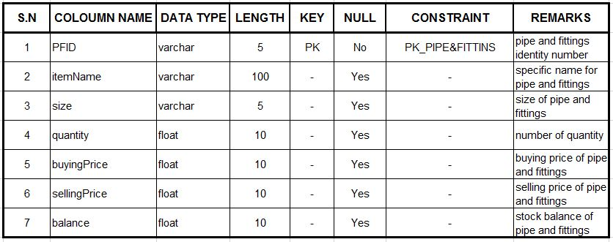

Figure 24: Data dictionary of table PIPE&FITTINGS

Data dictionary of table SALE

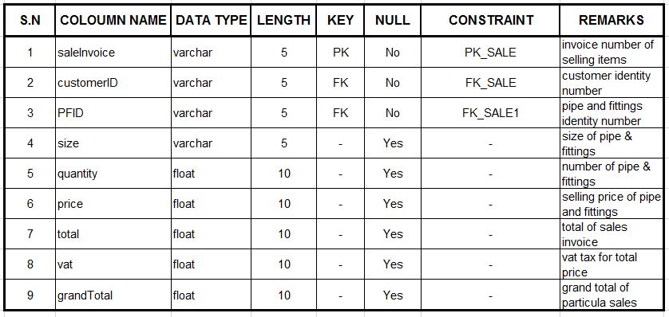

Figure 25: Data dictionary of table SALE

Data dictionary of table STAFFCUSTOMER

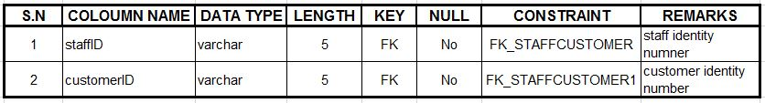

Figure 26: Data dictionary of table STAFCUSTOMER

Data dictionary of table STAFFSUPPLIER

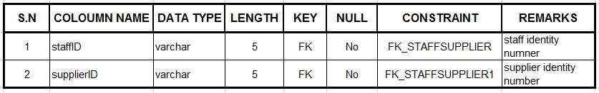

Figure 27: Data dictionary of table STAFFSUPPLIER

Data dictionary of table STAFF_TYPE

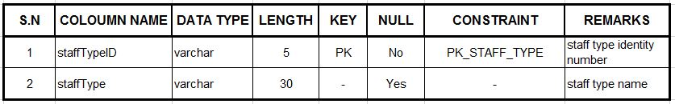

Figure 28: Data dictionary of table STAFF_TYPE

## Conclusion

Finally, the designing phase was completed successfully. Though the diagram construction was a bit difficult, proper guidance of tutor helps me to complete this phase. The designing was done with different type of UML diagrams which gives meaningful information to the viewers. The designing was divided into three different parts Structural, Behaviour and Database design for better understanding. Structural design consists of class diagram, Behaviour diagram consists of activity diagram and sequence diagram whereas Database design consists of ER diagram and data dictionary in this project.The diagrams are constructed in StarUML and Visual Paradigm which has all the necessary tools to make the diagram meaningful. Class diagram is constructed in StarUML whereas all the other diagrams such as Activity diagram, ER diagram, Sequence diagram are construct in Visual Paradigm. Data dictionary were built in MS Excel. With the help of these diagram development (coding) of system has been much easier.

# Implementation

The way of carrying out the developed system into a working condition is known as implementation of the system. I have used design to begin the implementation and coding phase. If the system structure is designed properly and system requirements are gathered accurately then the implementation process can be easily done. During implementation, actual system is created. Implementation can be conversion of old system to new system or entirely new system to a particular organization. There are different types of implementation process such as parallel implementation, direct implementation, pilot implementation and phased implementation. Among them suitable implementation approach is carried out according to environment of the organization.

## Programming Language and Web design

I have used Hyper-Text Markup Language (HTML 5), Hyper-text Preprocessor (PHP), Cascading Style Sheets (CSS), JavaScript and Bootstraps programming languages using Code Igniter framework and MySQL database for developing this Hardware Sales and Purchases System (HSPS). Following languages, framework and database is being slightly define below.

### Hyper-text Preprocessor (PHP)

PHP is a powerful tool for developing dynamic and interactive Web pages. It is an open source scripting language as well as widely-used which is executed on the server. It main propose is to collect the data and manipulate them in database server. It can send and received cookies, encrypt data and also control user-access. It is platform independent as well as compatible with most of popular servers like Apache, IIS etc. It is free to download and easy to learn.

### Hyper-Text Markup Language (HTML 5)

HTML 5 is the language that web pages are written in. HTML 5 is the backend language that makes us able to see stuffs online. Before HTML 5 was introduced the webpage needs to depend upon third party software such as Adobe flash player, Windows media player to play audio and video files, graphics etc. HTML 5 is now capable of such stuff so the web page won’t have to depend upon other parties. It supports video, audio, vector graphics and animation, drag and drop, editable web page content. Storage within the browser and many more. The overall hope is that someday it will create standard consistence web experiences among all the browser and devices.

### Cascading Style Sheet (CSS)

It describes style or design of the HTML tags or elements which are to be displayed on screens. One CSS file can control or style multiple web pages all at a once. It can be applied in three different ways external, embedded and inline style sheet. External style is applied by defining the link with its particular path in HTML file. It is created in different file located within the same folder where HTML is being saved. Embedded style is created within the HTML file by opening <style> tag whereas Inline style is also created within the HTML file but for particular tag or element only.

### Java Script

Java script describes the behavior of web pages. Java script is a programing language that enhance the user experiences. It is an action that are performed in the web pages and to provide some certain message, calculation and information that is being currently carried out in the web pages It is not just used to programing a browser but also server, game, database and also used in robotics.

### Bootstraps

Bootstraps is an open source framework for HTML, CSS and JavaScript that makes a web browser more responsive and active as well as makes them suitable for mobile devices also. It is a predefined CSS file that can be easily downloaded and apply into HTML pages for attractive and responsive web page. It saves lots of time which could have been wasted in making CSS files. It can be used with any server-side technology and any platform with any web application.

### Code Igniter Framework

It is an open source PHP web application framework that provides logical structure and reusable interface. It has better performance because of being lightweight. By changing the certain line of codes we can use code igniter and make our own object oriented web pages. The components in it can be reused on multiple projects and its maintainability. It uses MVC pattern for organizing code and logic. And the codes and logic of it are being uploaded to Git to keep better track between the codes.

### MySQL

It is most widely used open source database management system around the world. It is owned by Oracle Co-operation. It is a Relational DBMS in which database structure are organized into physical files for better performance. The database server is reliable, fast, scalable and easy to use. It works as a client/server or embedded systems. It can handle and work with large numbers of data along with various programing language.

## Development Environment

### Integrated Development Environment (IDE)

I have used Notepad++ v7.4.1 32-bit as an IDE for coding the architecture of Hardware Sales and Purchases System. It supports multi tabbed in single window which allows me to open multiply files at once that makes easier to work and enhance in performance. It main features are multi-view, zoom in zoom out, multi-language environment support, auto-completion, tab interface and many more. It is independent text editor capable with different OS such as Microsoft windows, Classic Mac OS, LINUX and UNIX.

### Development Platform

The HSPS was fully developed in Microsoft Windows platform and the OS used was Windows 10 Pro 64-bit (10.0, Build 15063).

## Development Strategy

This is the process of figuring out the needs and objectives of system and making the changes to meet them.

### System Migration

It refers to moving a set of business process related to IT to newer hardware infrastructure and software implement from existing system to enhance the performance and being up to date with current technologies to gain more value from business. Generally, it is done when the current system does not perform as expected or becomes deprecated and no any support is available for it. With rapid growing of cloud computing, many businesses are migrating their system into cloud with automated tools which migrates data and software in short period of time.

### Data Migration

It refers to transferring data between two data storage or computer systems or from one format to another. It occurs when a business process or organization decides to use a new computing system or database management system which is being currently used is no longer supportive. While data migration is carried out, automated software or scripts are used to map system data for better migration. It also occurs when some maintenance is going on with server and server or storage upgrades or replacements and data center relocation.

## User Training

The system does not provide better output until and unless the user of the system knows how to operate the system. Implementation only does not help for better result; deployment also must be done properly. Hardware Sales and Purchases System is an e-commerce web site through which buying and selling traction are carried out. The customer and owner of the shop must be able to be in contact to perform any transaction. The customer can view the products available and other them online. The staff and owner of the shop must be able to generate bill and add into database respectively. So, the users of this site must know the capabilities of this web site and they must know how to get best of it.

The following web site is user friendly with proper words and navigation which makes user of this website understand easily and help to known what action will be done by clicking through any link in it. It assists customer as well as staff/owner how to place order, view order and prepare bill for it and adding items in it. The website is responsive and can has better performance and can be run on any platform.

## Conclusion

Finally, the implementation phase of Hardware Sales and Purchases System (HSPS was successfully carried out. The analysis and design done in the previous phase helps me to encode the system architecture properly and smoothly. Programing language, Frameworks and Database with proper IDE helps me to implement the system efficiently. Interaction between the owner and staff helps me more to known the coding structure and how it must work. However, some of the difficulties were identified while developing but later on it was tackle down.

# Other Project Issues

## Project Management

It is the process of managing any ongoing project with knowledge, skills, alternative methods and experience to achieve project goals and objectives. It consists of capturing requirements of project, project budget specifying quality of deliverables and scheduling each and every activity to track down how much the project have been developed. Simply, it’s about getting things done in proper manner, knowing what exactly you are trying to achieve, how to you are going to achieve and how long it will take. It ensures everyone involve in the project understand its need and share their view upon it. A well-managed motivated team with clear role and responsibilities and ability to report at right time will carry a project to its conclusion without compromising on quality, cost and time. Proper planning and frequent communication with stakeholders and project team leads to accomplish the project successfully.

## Risk management

A risk can be characterized into three components i.e. the events, the probability of event occurrence and impact made by that even to the project. It refers to identifying and understanding most possible risk and analyzing and addressing them well enough so that it won’t hamper the performance of system as well as ongoing project. It is a set of coordinated activities that helps to eliminate and control risk.

Risk management is the best accomplished activity when a set of well documented guidelines and standard operating procedures are implement and followed by each and every individuals of the company. It an ongoing process that continues through the project`s life to maintain and prevent from risk.

As I compare with the proposal risk I have taken different action for preventing from such risk.

### Identifying Risks

* Event-driven risks
* Failure to save files.
* Hard disk crashing.
* Laptop OS crashing.
* Long term or chronic risks
* Wrong formulas.
* Bad estimation of functions.
* Bad analysis.
* Technical risks
* Are specific methods used for software analysis?
* Are code and documents defined?
* Are software supports the analysis and design process? Etc.
* Non-technical risks
* Natural calamities.
* Sickness.
* Busy schedule.

### Assess of impact of risks.

* Risk likelihood

|  |  |
| --- | --- |
| **Risk likelihood** | **Score** |
| Low | 1 |
| Medium | 2 |
| High | 3 |

Figure 29: Risk likelihood values

* Risk consequences

|  |  |
| --- | --- |
| **Risk Consequence** | **Score** |
| Very low | 1 |
| Low | 2 |
| Medium | 3 |
| High | 4 |
| Very high | 5 |

Figure 30: Risk consequence values

* Impact = Likelihood * Consequence

The risk management table is given below.

|  |  |  |  |  |
| --- | --- | --- | --- | --- |
| **Risk** | **Likelihood** | **Consequence** | **Impact** | **Action** |
| Failure to save files. | 1 | 4 | 4 | Implementing automated system which saves the files automatically if there is no any changes for certain time. |
| Hard disk crashing. | 1 | 5 | 5 | I have save my file into the cloud so we don’t have to worry about hard disk crahsing. |
| Laptop OS crashing | 1 | 3 | 3 | Protecting from malware and viruses. |
| Wrong formulas. | 2 | 3 | 6 | By understanding what it actual does, the formulas was easily solved. |
| Bad estimation of functions. | 3 | 4 | 12 | The function was prepare with a specific purpose and were used properly. |
| Bad analysis | 3 | 5 | 15 | Proper analysis of project and its requirements |
| Are specific methods used for software analysis? | 2 | 4 | 8 | Checking the methods or testing them time and again. |
| Are code and documents defined? | 3 | 4 | 12 | Good application is only possible when the codes are corrected so proper documentation of codes and its functions. |
| Are software supports the analysis and design process? | 2 | 5 | 10 | Proper analysis and designing must to done to prevent from such risks. |
| Natural calamities | 1 | 5 | 5 | Proper back up of data and documents must be done for further use. |
| Sickness. | 1 | 4 | 4 | Health should be cared and maintain time and again. |
| Busy schedule | 1 | 3 | 3 | Time schedules should be well managed so that the project can be completed in time. |

Figure 31: Risk Management table for HSPS.

## Configuration Management

Configuration management is the process of identifying and tracking down the task that have been carried out while developing a software. It increases efficiencies, stability and control by improving visibility and tracking. It keeps the historical records of the system state like what changes has been done and identify the fault cause by possible changes. It helps to decrease risk and provides higher level of security.

I have chosen GitHub to save all the data and information related with this project. GitHub is a platform to share ideas among the team, it helps to manage chaos, show how many task has been completed and task to be completed. It is like a cloud storage so data if the system crashes then GitHub will help to recover the file. All the files related to the project is kept in GitHub in organized way so it will be easy to access and find any folder we need. I have also used Google Drive to keep the data and documents related to this project safely and can be easy to access anywhere any time.

## Testing

Testing is the process of executing and evaluating a system to known whether it fulfilled the specified requirements of HSPS or not. It consists of finding out how well does the developed system works? is it worth it or not? does it fulfill the requirements that are being identified? It is used to detect differences between current system and required system as well as to evaluate the features of the system

There are different types of testing which can lead to build a good system. Some of them are as follows:

### Unit Testing:

It is the process of testing an individual unit or group of related units. Each and every function are tested one after another by the programmer whether it is functioning as needed or not. It comes under white box testing.

### White Box testing:

It’s a testing related to internal structure of the system. It only deals with process involve in the system rather than input and output of the system. It is used for verification. Under white box testing there are several testing, among them some of them are explained below:

1. **Data Flow testing:**

It will verify the data that have been passed in the process. It will focus on which variables have received the data and in which point these data is used.

1. **Path testing:**

It will test each and every path from where the data is being transferred.

1. **Loop testing:**

It will execute until the given condition becomes false and testing whether it is working properly or not.

1. **Condition testing:**

It tests the given condition whether it is worth it or not and does it performs well or not.

### Black Box testing:

It`s a testing related to external structure of the system. It deals with input and output of the system rather than process involved in it. It is often used for validation and for execution of the system. Some of the black box testing are done for the HSPS project.

* 1. **Regression testing**

It`s a testing that takes place after any modification on the system, unit, method is done to ensure that the modification done in it is worthwhile.

* 1. **Functional testing**

It ensures that the functions that have been used to fulfill requirements in the system has works or not

* 1. **System testing**

It is used to ensure that the implemented system works in the different environment or not. Is it dependent or independent system?

* 1. **Performance and usability testing**

It’s a testing used to ensure system effectiveness and performance as well as time taken while generating results is acceptable or not. Whereas usability testing is done to evaluate the GUI from client perspective.

### Integration testing

It a testing done to a group of function that are combined together to produces an output. It also tests the interaction between hardware and software used in this project.

Here are some testing done for HSPS project. It shows tested unit, input given in for it, expected result, result obtained from it and its description with remarks.

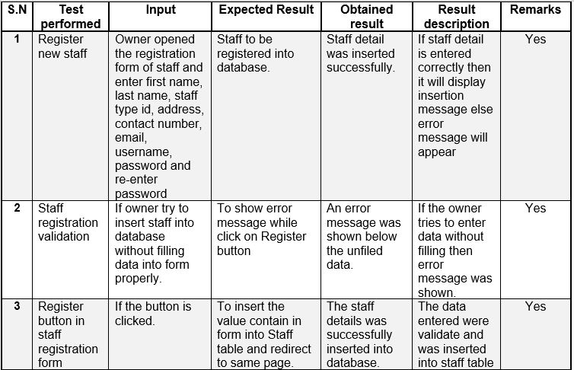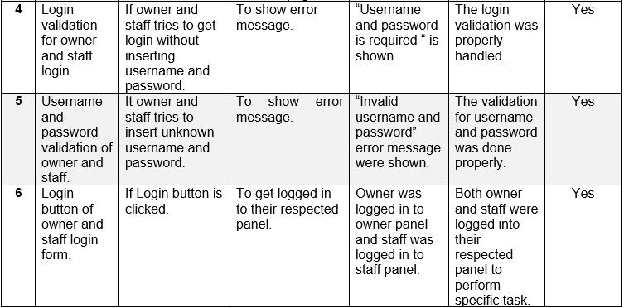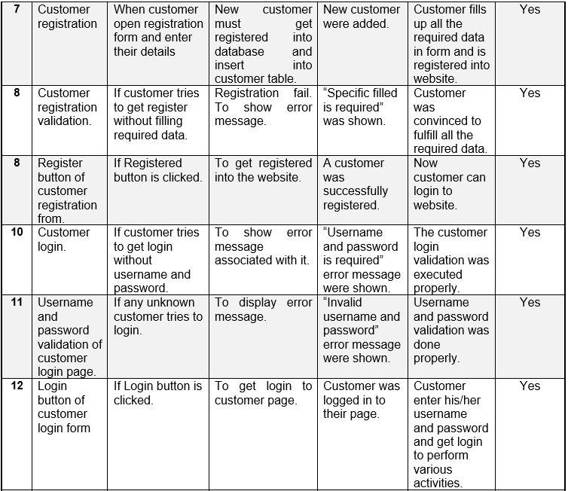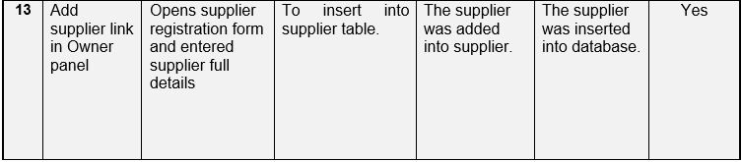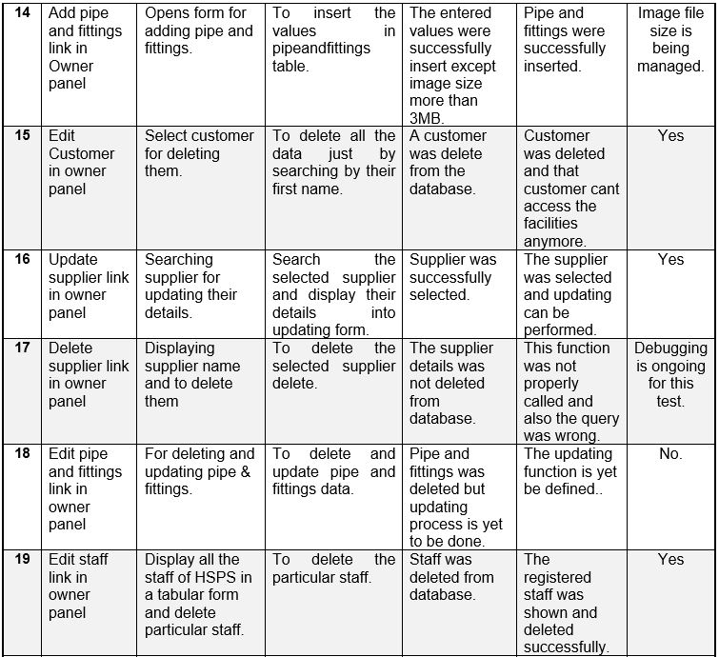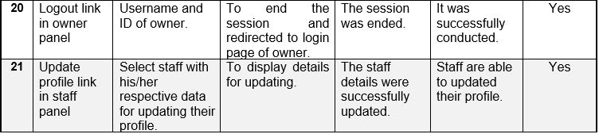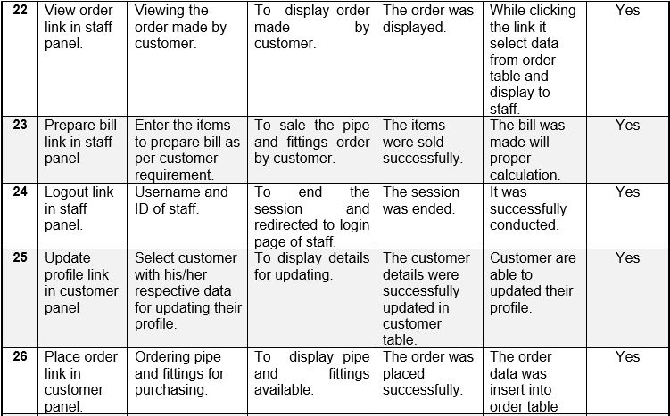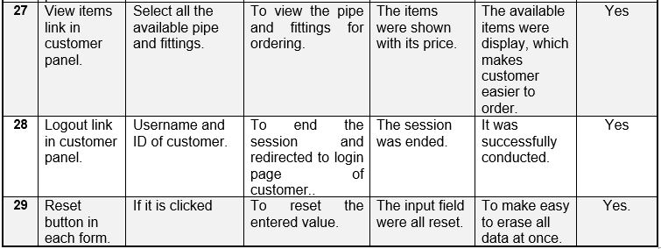

Figure 32: Test report of HSPS project.

# Conclusion

Finally, the HSPS project was developed successfully. The analysis, design, implementation and testing was done following Waterfall methodology. This methodology helps me a lot to accomplish this project. first the analysis was done. For this I visited to shop and done proper analysis and communicated with manger, staff and customer to understand their needs and system requirements. I prepared some questionnaire before visiting them and asked one by one thoroughly while communicating with them. With this also I get to understand more and more. Analysis was also further divided into different activities such as rich picture, system requirement specification (SRS) which consists of functional and non-functional requirements. After that MoSCoW prioritization was done. Use case diagram was also developed while analysis to know activities that are performed by interacting system and stakeholders. System architecture and initial class diagram was also defined in this phase.

After the completion of analysis phase, design and implementation was done. With the proper analysis, it helps me lot while designing and implementing (coding) project of HSPS. In designing phase, I have done structural, behavioral and database design. Structural design consists of class diagram which defines the methods and function used in it, Behavioral design consists of activity and sequence diagram which refers to task carried out by a stakeholders and process involve in it respectively. And database design consists of ER diagram which defines the entities and relation among those entities and Data Dictionary which defines meta data of those defines entities. Implementation is the process of converting those design into real system. In this phase the actual system is built. I have developed this website in PHP language with Code Igniter framework. Other web design was done by using HTML5, CSS, JavaScript and Bootstrap.

At last, the testing was done for the developed system. In testing phase unit testing, white box testing, black box testing and integration testing was done. It was done in each and every function, unit of HSPS unit and proper documentation and reporting was also done.

So, this is how the HSPS project was develop.

# Future works

HSPS project was developed successfully without any problem but there are some features, objectives and additional work which I want to develop in future to make the website. It also includes some of the function and features mentioned in the proposal but can`t be deliver at a time. There are listed below:

1. To make online payment for product that have been ordered.
2. To develop chatting services so that customer can do instant enquiry on the pipe and fittings they want.
3. To do online purchasing with supplier as well.
4. Also provide platform for support for to those customers who are loyal to the shop.
5. Feedback section to know the customer satisfaction and dis-satisfaction towards particular items or with the services that are being currently running.

# References

*List of risks*. (2017, April 20). Retrieved from http://groups.engin.umd.umich.edu/CIS/course.des/cis375/projects/risktable/risks.htm

Lucidchart. (2017, April 16). *Class Diagram Tutorial*. Retrieved May 20, 2017, from https://www.lucidchart.com/pages/uml/class-diagram

Lucidchart. (n.d.). *Activity Diagram Tutorial*. Retrieved May 20, 2017, from https://www.lucidchart.com/pages/uml/activity-diagram

Lucidchart. (n.d.). *Class Diagram Tutorial*. Retrieved May 20, 2017, from https://www.lucidchart.com/pages/uml/class-diagram

Lucidchart. (n.d.). *Sequence Diagram Tutorial*. Retrieved May 20, 2017, from https://www.lucidchart.com/pages/uml/sequence-diagram

Lucidchart. (n.d.). *What is an Entity Relationship Diagram*. Retrieved May 21, 2017, from https://www.lucidchart.com/pages/er-diagrams

ReQtest. (2017, April 15). *FUNCTIONAL REQUIREMENTS VS NON FUNCTIONAL REQUIREMENTS* . Retrieved from http://reqtest.com/requirements-blog/functional-vs-non-functional-requirements/

Solutions, D. (n.d.). *Introduction to database design*. Retrieved May 21, 2017, from http://www.datanamic.com/support/lt-dez005-introduction-db-modeling.html

TechTarget. (2017, March). *configuration management (CM)*. Retrieved from http://searchitoperations.techtarget.com/definition/configuration-management-CM

times, P. (2012, May 17). *10 Steps To Creating A Project Plan*. Retrieved from https://www.projecttimes.com/articles/10-steps-to-creating-a-project-plan.html

tutorialspoint. (n.d.). *ER Model - Basic Concepts*. Retrieved May 21, 2017, from https://www.tutorialspoint.com/dbms/er_model_basic_concepts.htm

tutorialspoint. (n.d.). *UML - Activity Diagrams*. Retrieved May 20, 2017, from https://www.tutorialspoint.com/uml/uml_activity_diagram.htm

tutorialspoint. (n.d.). *UML - Class Diagram*. Retrieved May 20, 2017, from https://www.tutorialspoint.com/uml/uml_class_diagram.htm

tutorialspoint. (n.d.). *UML - Interaction Diagrams*. Retrieved May 20, 2017, from https://www.tutorialspoint.com/uml/uml_interaction_diagram.htm

WebStrom. (n.d.). *Software QA and Testing Reasearch Center*. Retrieved May 21, 2017, from http://sqa.fyicenter.com/FAQ/Testing-Techniques/What_is_the_difference_between_top_down_and_bott.html

# Appendices

## Appendix A

**Test scripts**

Here are some of test reports that have been identifies while reporting testing.

Testing for customer login.

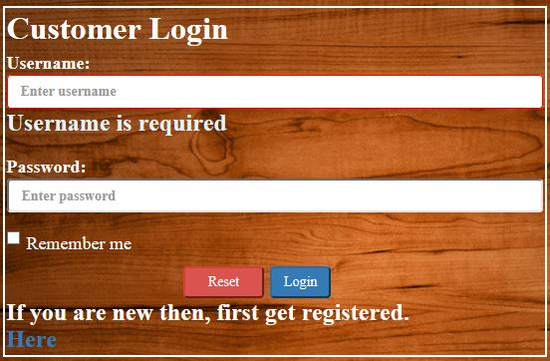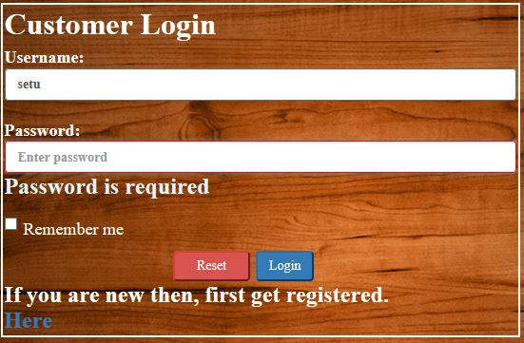

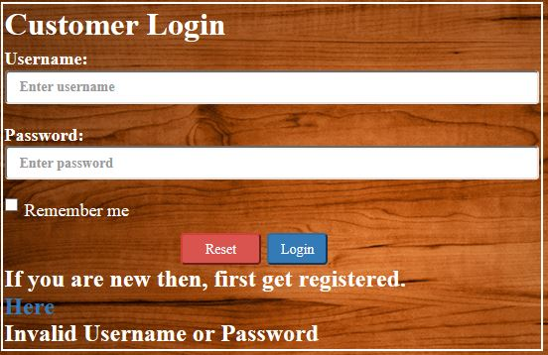

Testing for owner and staff login.

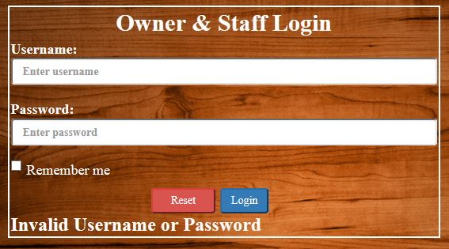

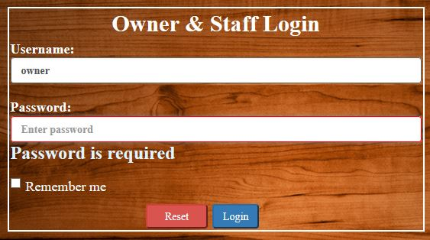

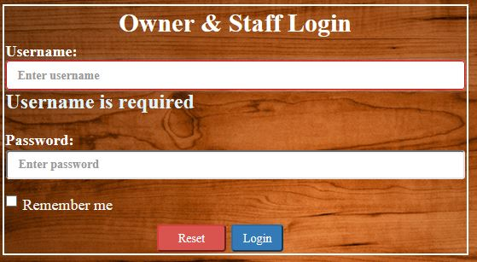

Testing for where the item is deleted or not.

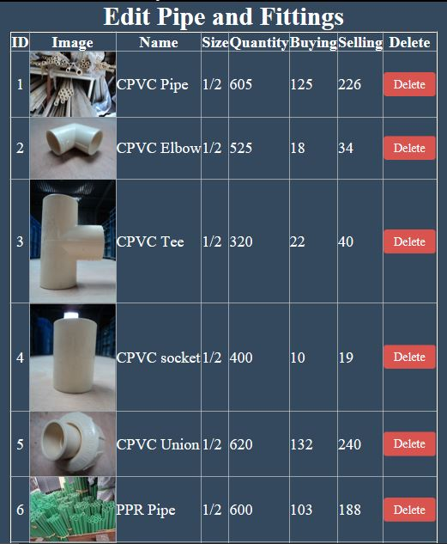

Searching for supplier to updated their details.

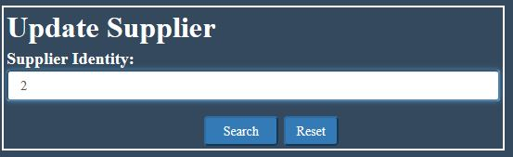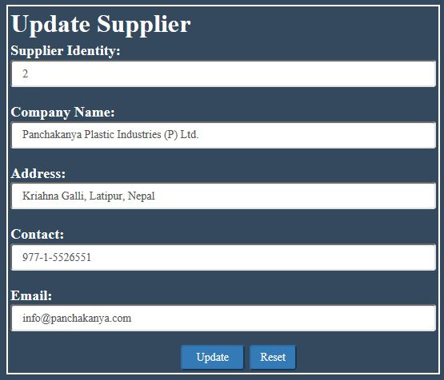

Testing validation for customer registration.

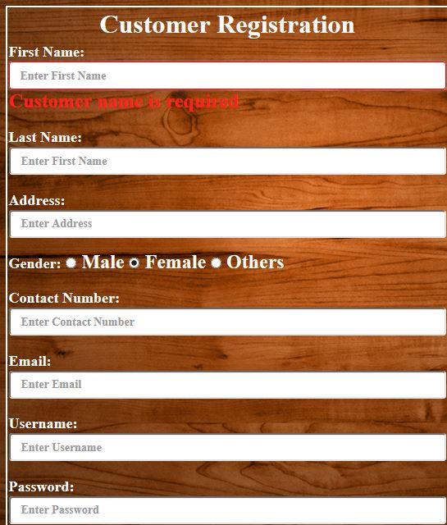

Testing validation for staff registration.

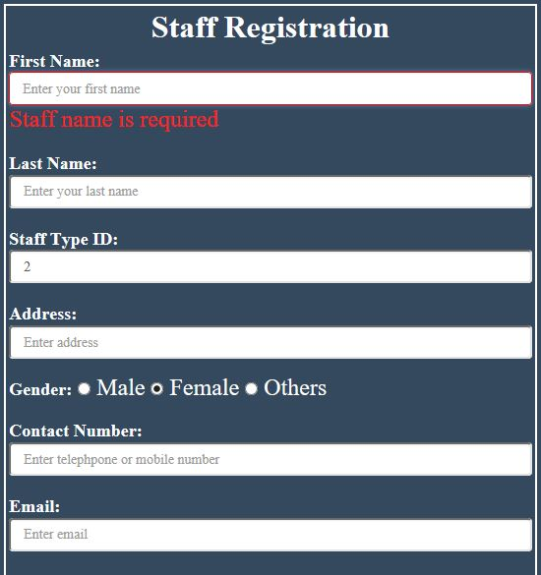

## Appendix B

**User guide**

* + - * **User manual for Owner.**

You are the owner of the HSPS so you have been registered before with predefined username *owner* and password *owner.* So, you just need to go in owner/staff login page and insert username and password for further access.

Here is the Owner panel where all the activities are being carried out.

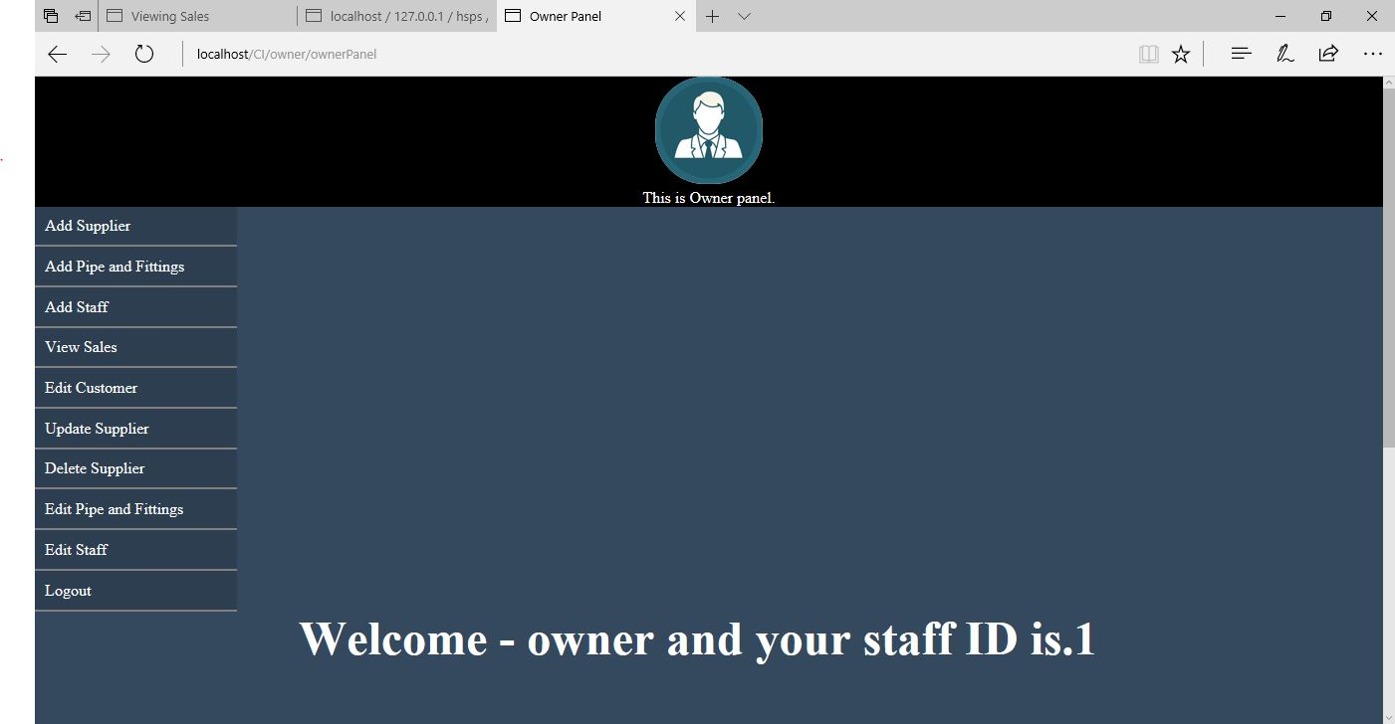

Here, the list of activities is being describe briefly for you to user them easily in this website.

1. For adding new staff.
2. First, you have to click on Add Staff link.
3. Then staff registration page will open then insert staff details in required fields.

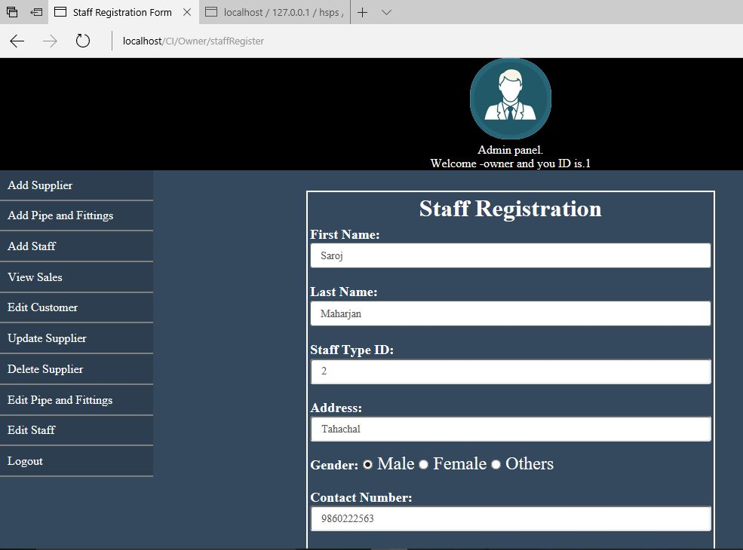

1. Then click on *Register* button to register staff or *Reset to clear all the input fields.*

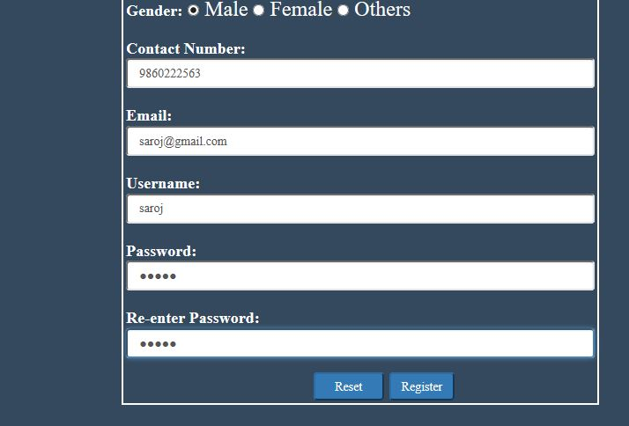

1. For adding pipe and fittings
2. First, you have to click on Add Pipe and Fittings link.
3. Then pipe and fittings form will appear, insert values for each fields.

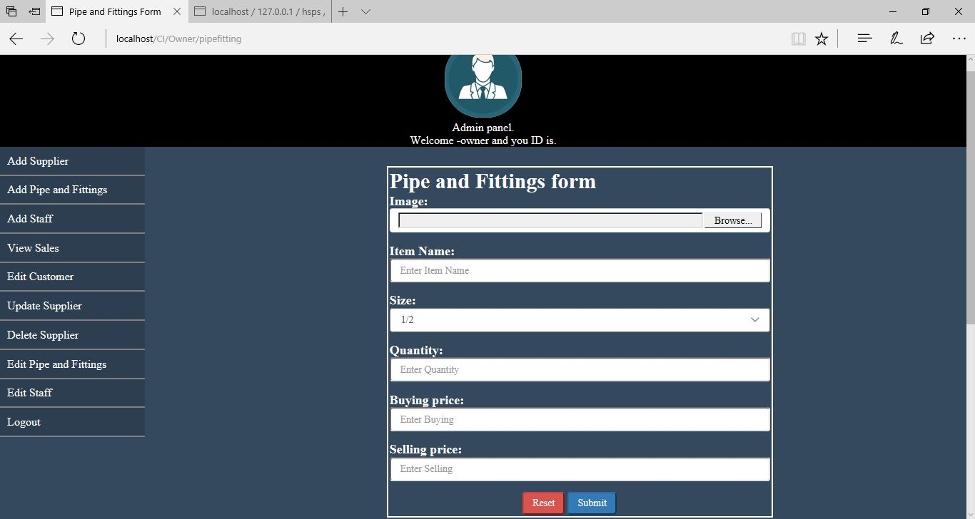

1. Then click on *Add* button to add or *Reset* button to clear.
2. For adding supplier
3. First, you have to click on Add Supplier link.
4. Then supplier form will appear, insert values for each required fields.

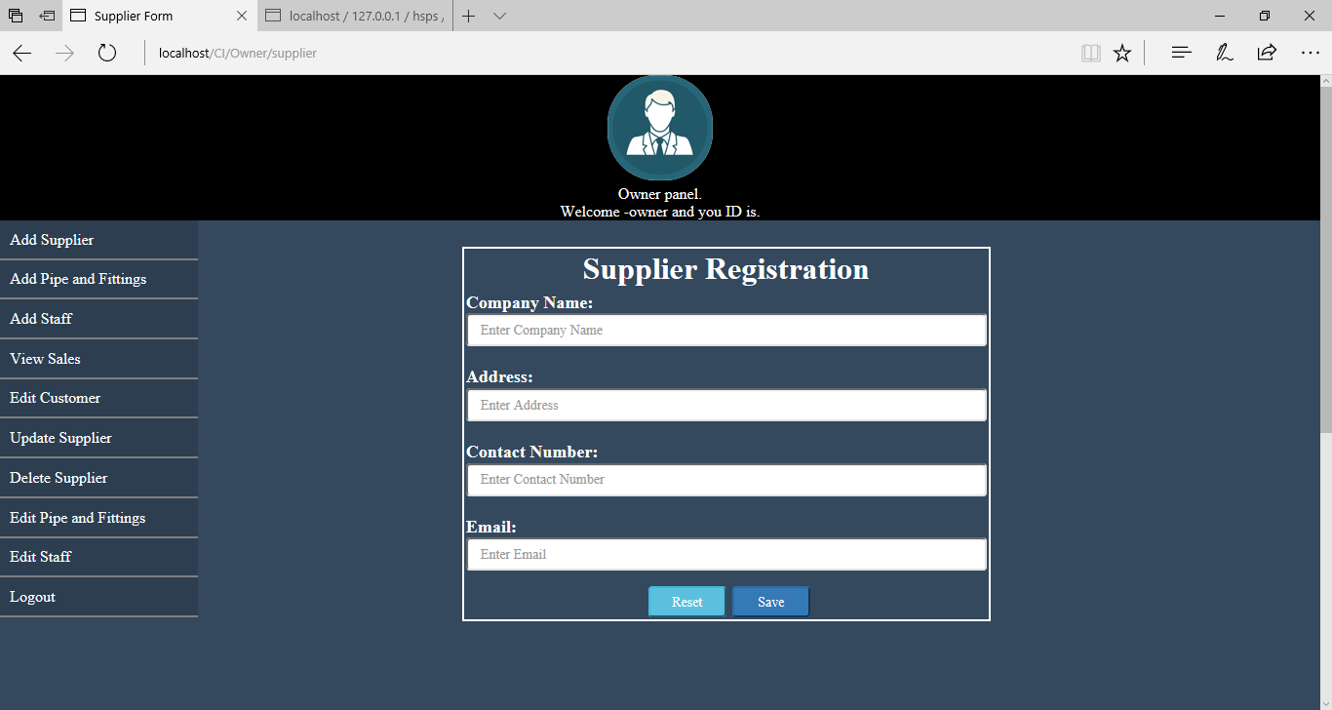

1. Then click on *Save* button to add or *Reset* button to clear.
2. For editing customer.
3. First, you have to click on Edit Customer link.
4. Then Delete Customer form will appear where you can search customer by their name.

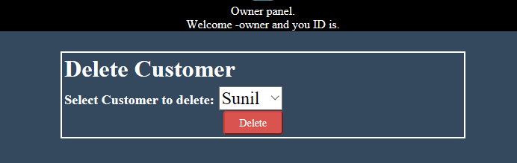

1. Then click on *Delete* button to delete customer.
2. For update supplier
3. First, click on Update Supplier link.
4. Then, search the supplier you are willing to update their details by their ID.

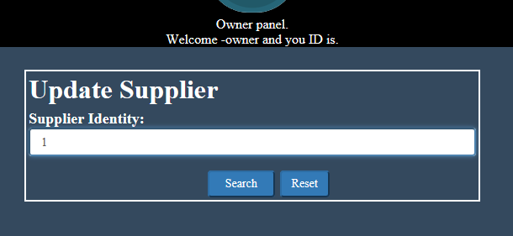

1. Then, fill the data field you are trying to update.

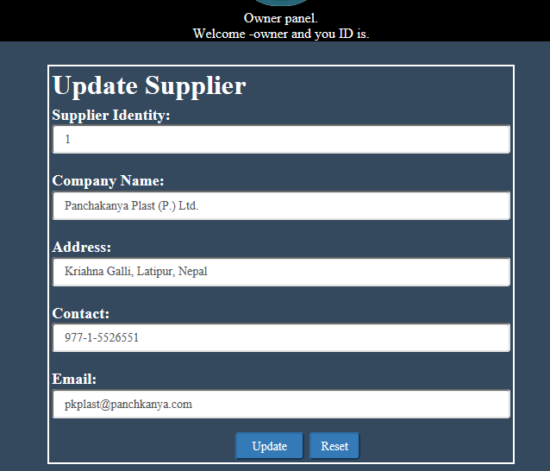

1. Then, click on *Update* button to update supplier details.
2. For viewing sales.
3. First, click on View Sales link.
4. Then it will display the sales that have been made till date.

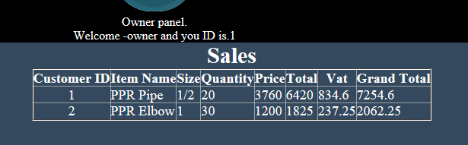

1. For deleting supplier.
2. First, click on Delete Supplier link.
3. Then search by their company name.
4. Click on *Delete* button to delete supplier.

(Note: This function is yet to test because of some bugs it can`t run this function. Sorry for the trouble.)

1. For editing pipe and fittings.
2. First, click on Edit Pipe and Fittings link.
3. Then it will display available pipe and fittings.

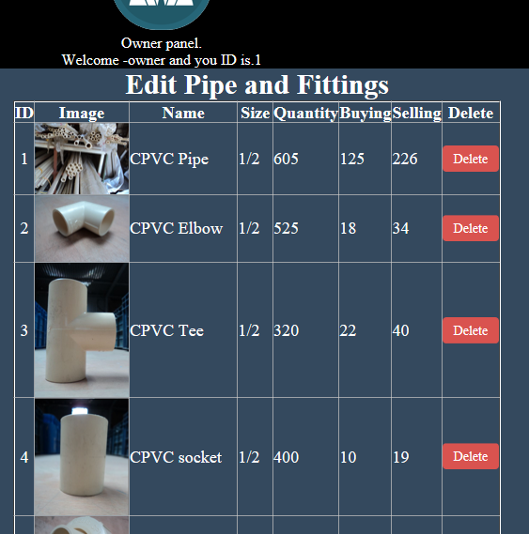

1. Then click on *Delete* anchor to delete a particular pipe and fittings at a time.
2. For editing staff.
3. First, click on Edit Staff link.
4. Then it will display all the necessary information of staff.

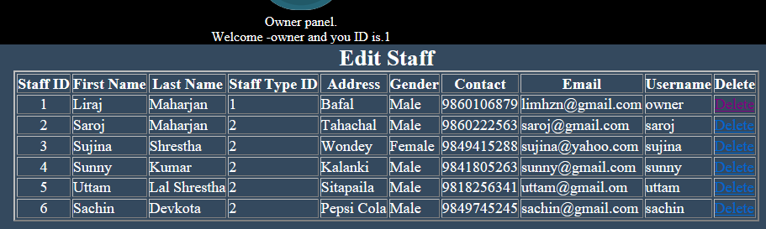

1. Click on *Delete* link to delete particular staff.
2. For logout.
3. Click on *Logout* link.
4. Then it will redirect you to owner staff login page.
   * + - **User manual for Staff.**

This is the Staff panel where staff can perform his/her activity.

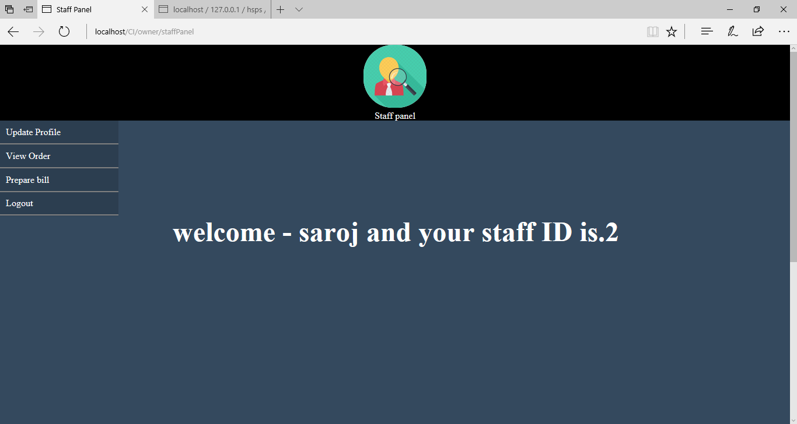

1. For updating profile.
2. First, click on Update Profile link.
3. Then, the staff updating form will appear and insert the information you are willing to update.

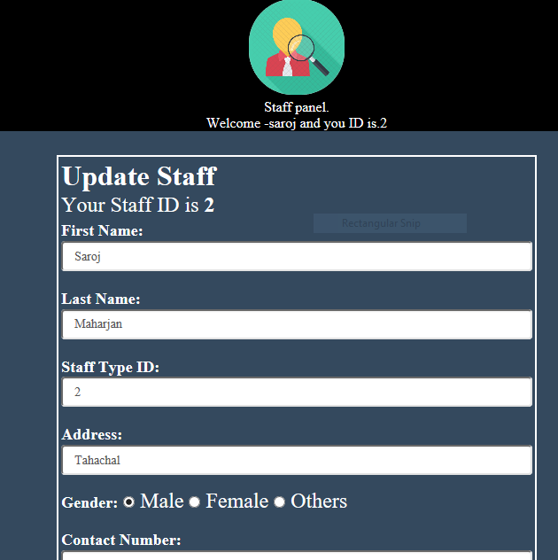

1. Then click on *Update* button to update or *Reset* button clear.

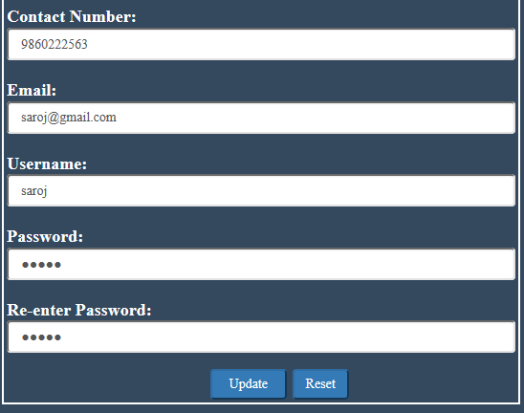

1. For viewing order.
2. First, click on View Order link.
3. Then will show all the order that has been left for to be cleared.

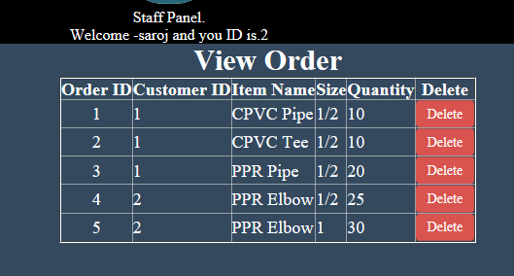

1. He/she can also delete the order if the stocks are not available at the moments.
2. For preparing bill.
3. First, click on Prepare Bill link.
4. Then search for the customer for whom want to make bill.

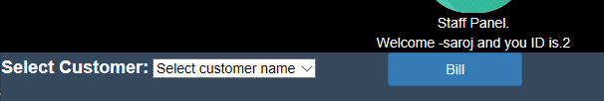

1. Then click on *Bill* to generate the bill.

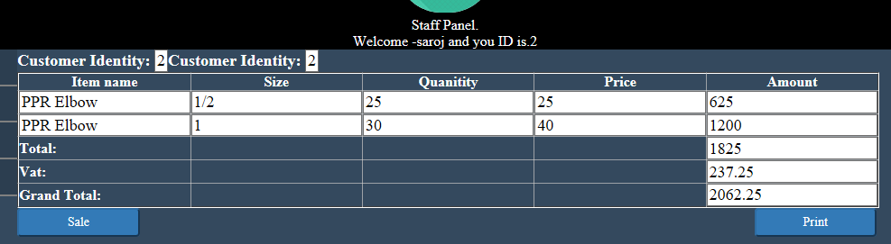

1. Click on *Sale* button to insert them into sale table and *Print* button to print the bill.
2. For Logout.
3. Click on *Logout* link.
4. Then it will redirect you to owner staff login page.
   * + - **User manual for Customer.**

Here, is the Customer Panel where customer can perform following activities.

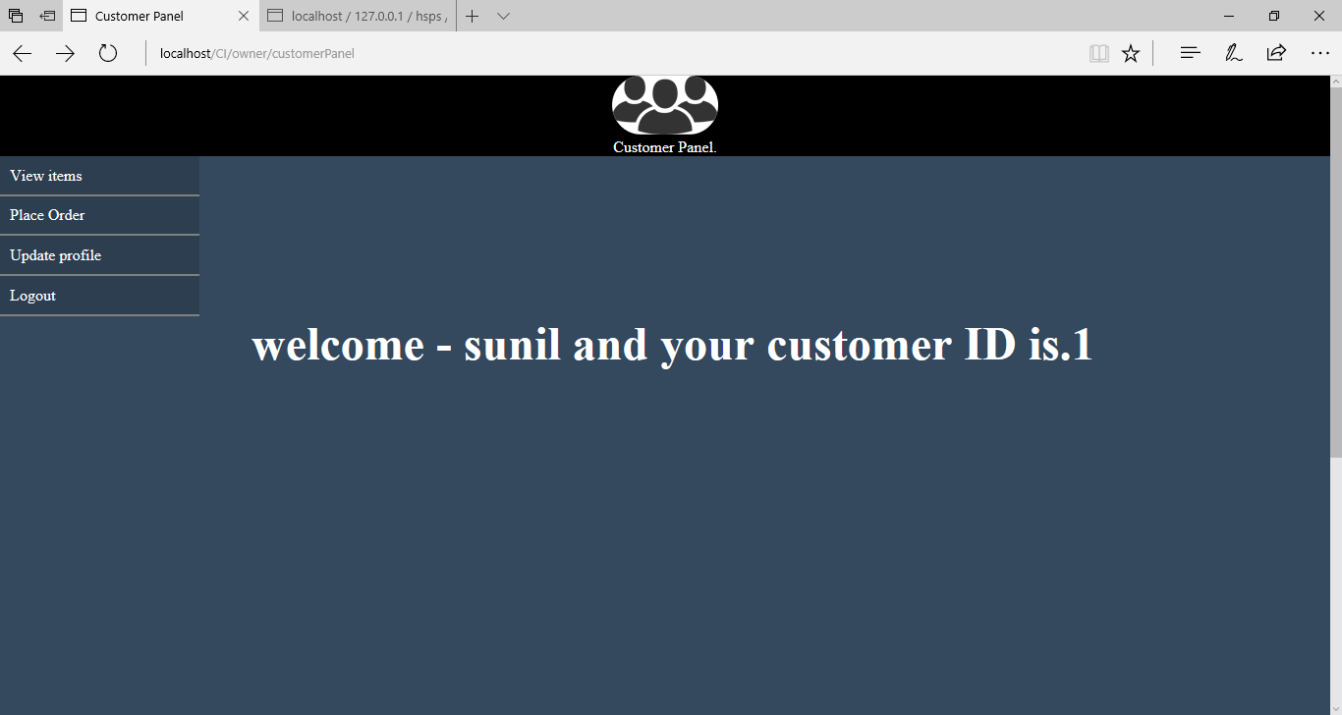

1. For viewing pipe and fittings.
2. First click on View Items link.
3. Then it will display all the available pipe and fittings for you to order.

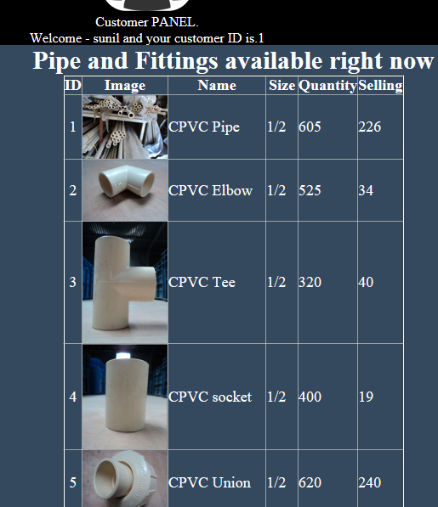

1. For placing an order.
2. First, click on Place Order link.
3. Then it will display the pipe and fittings available.

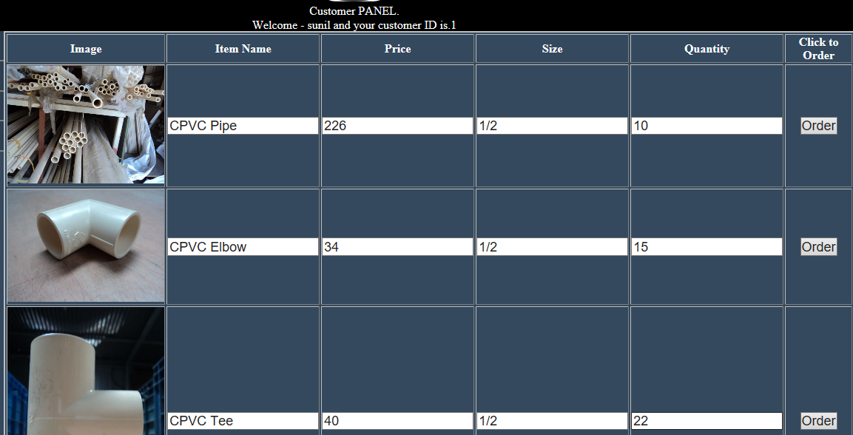

1. Then input the quantity that you want to buy.
2. Then click on *Order* button to finalize order.
3. For updating profile.
4. First, click on Update profile.
5. Then, the customer updating form will appear and fill the specific field that you want to update.

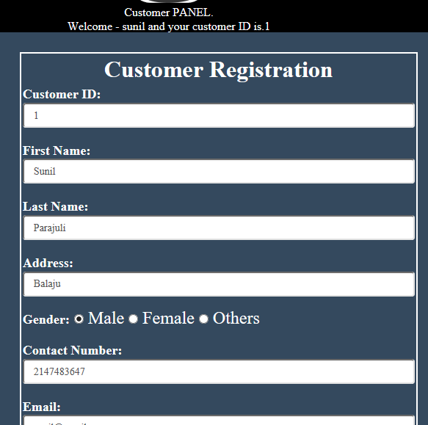

1. Then click on *Update* button to update or *Reset* button to clear.

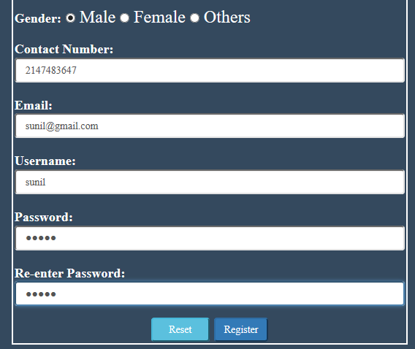

1. For Logout.
2. Click on *Logout* link.
3. Then it will redirect you to owner customer login page.

## Appendix C

**Source code of HSPS project.**

Here is some collection of HSPS source code. This isn’t overall codes of HSPS, but just a code from staff and customer controller and model.

For customer Registration

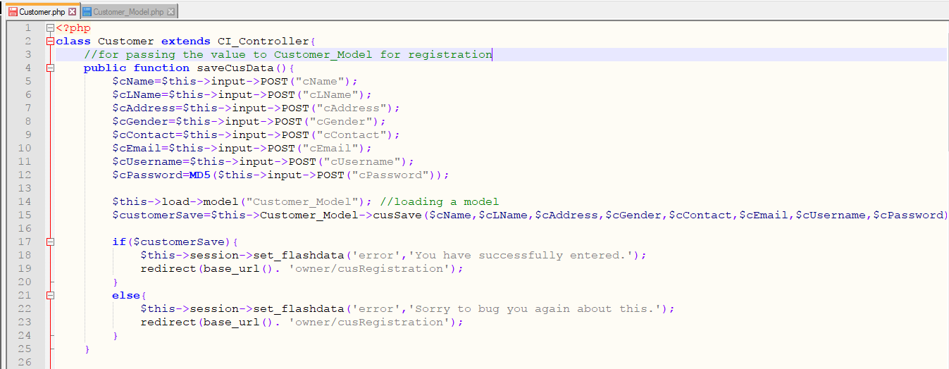 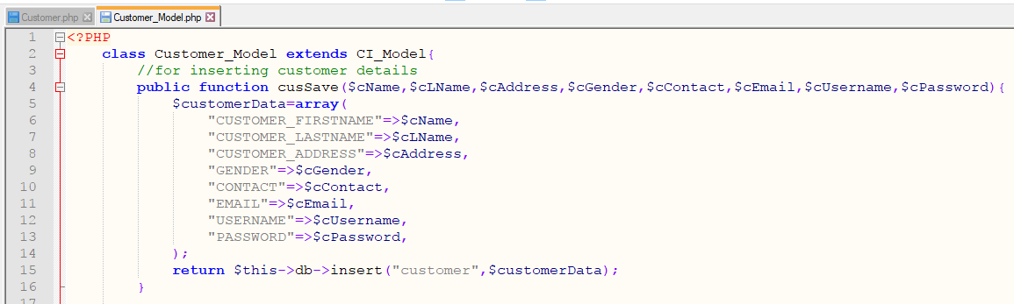

For customer Login

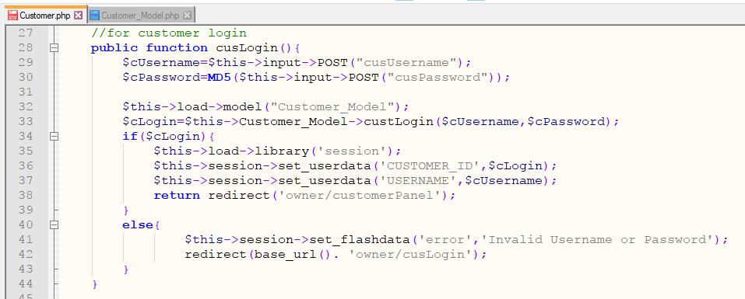

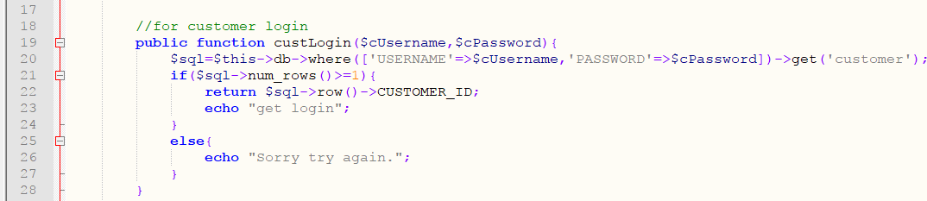

For staff Registration

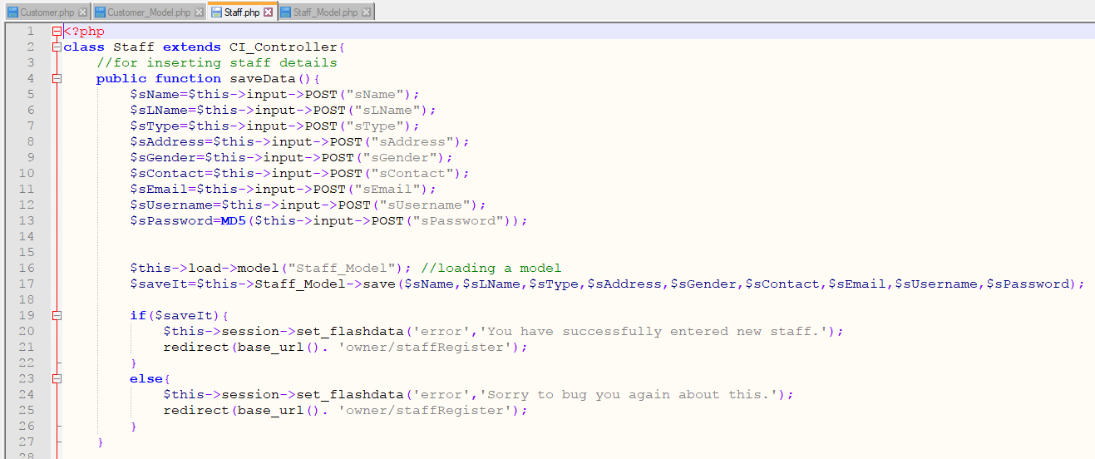 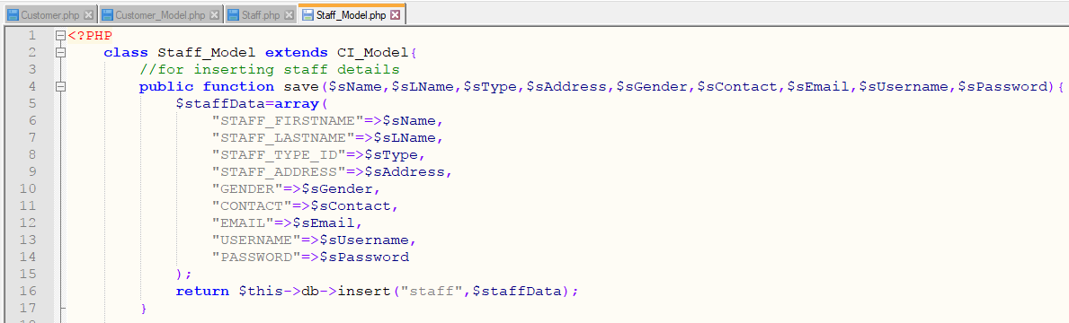

For Owner and Staff Login

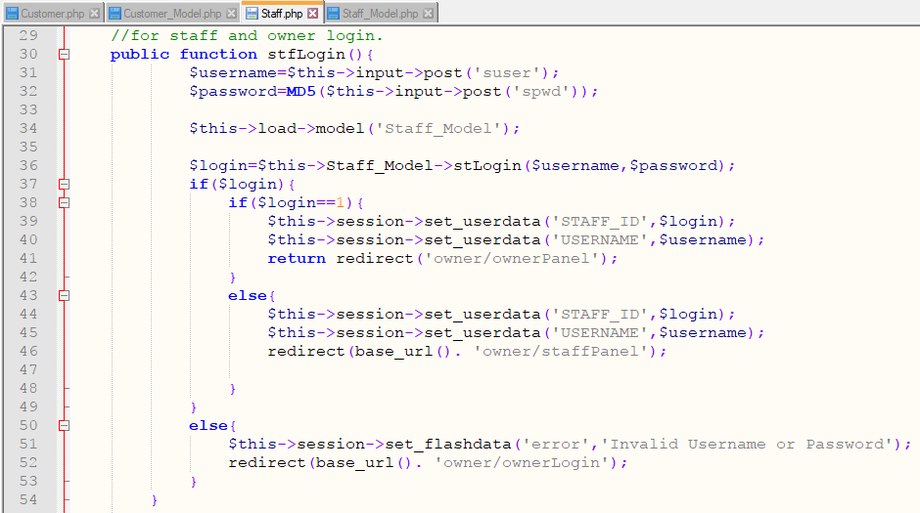 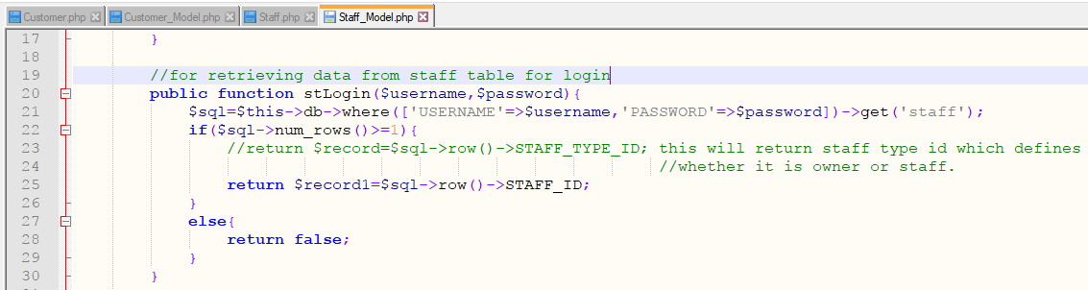

For adding Supplier

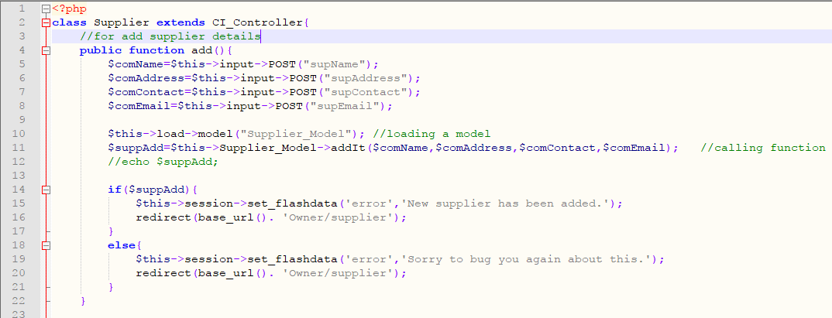 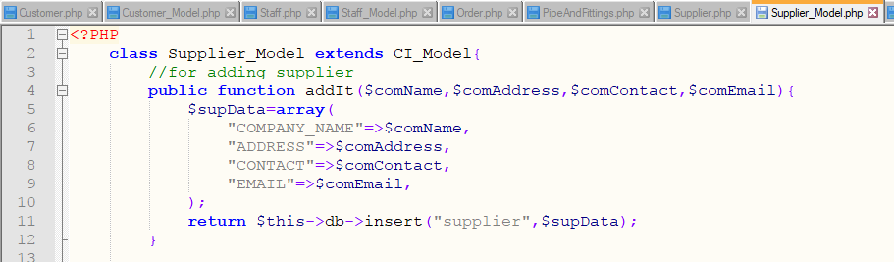

For adding Pipe and Fittings.

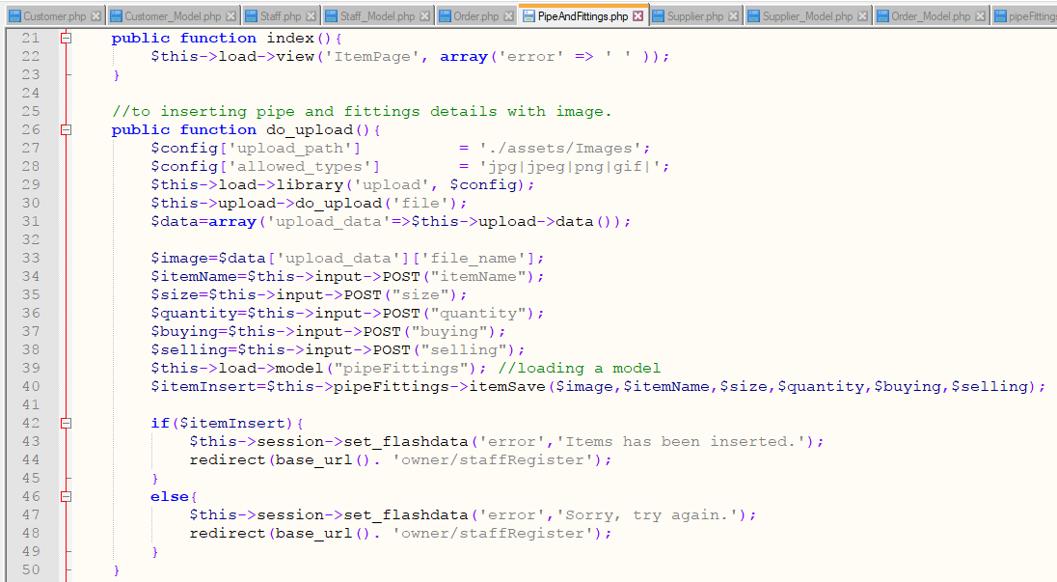 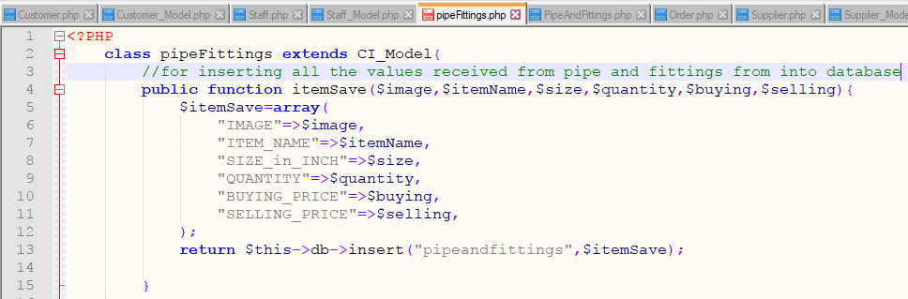

For placing Order

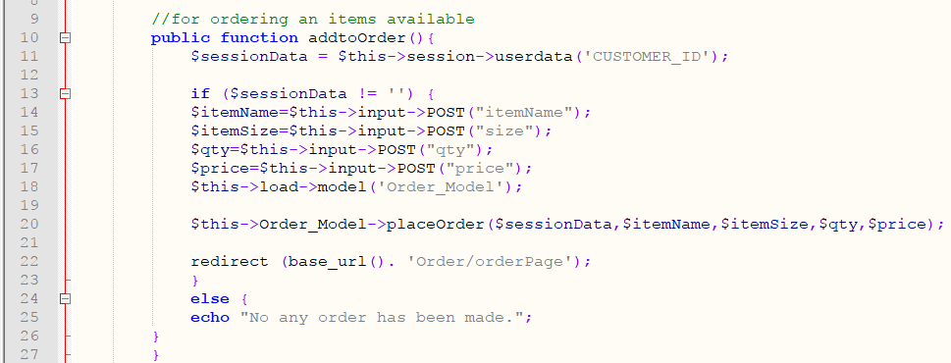

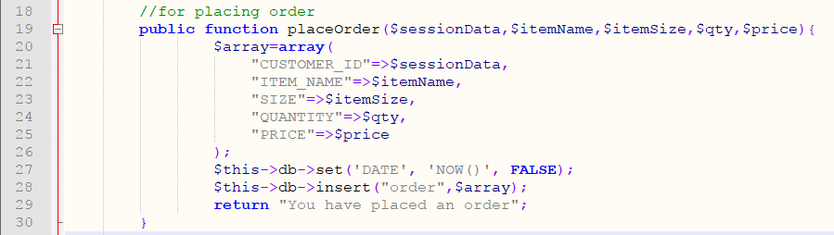

For preparing Bills and selling Items.

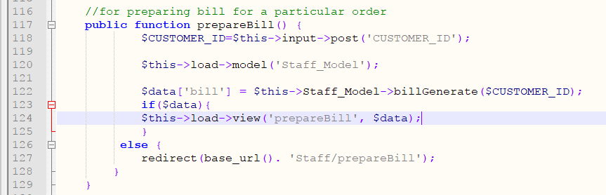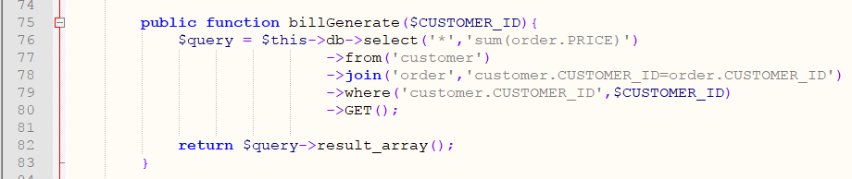

Selling items

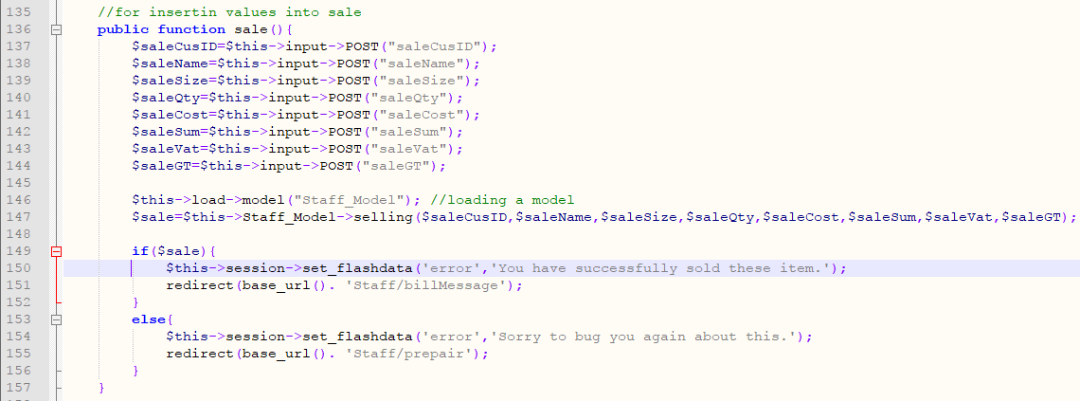

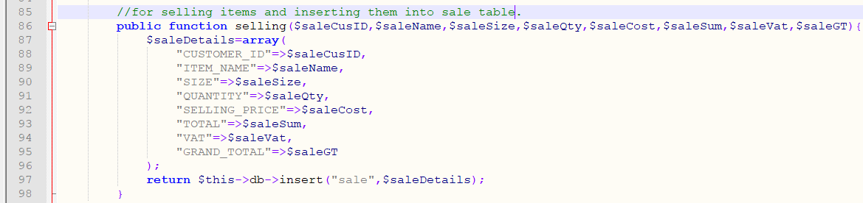

For Logout for Customer

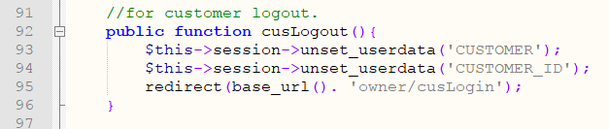

For Logout for Owner and Staff

